Honeywell Powder Amplifier

Final Proposal

Savana Bezdicek
Nicole Mitich
Luke Plumb
Isaac Romero
Jacob Setzer

2016-17



Project Sponsor: Honeywell
Faculty Advisor: David Trevas
Sponsor Mentors: Mike McCollum and Mitchell Thune
Instructor: David Trevas
DISCLAIMER
This report was prepared by students as part of a university course requirement. While considerable effort has been put into the project, it is not the work of licensed engineers and has not undergone the extensive verification that is common in the profession. The information, data, conclusions, and content of this report should not be relied on or utilized without thorough, independent testing and verification. University faculty members may have been associated with this project as advisors, sponsors, or course instructors, but as such they are not responsible for the accuracy of results or conclusions.

TABLE OF CONTENTS

DISCLAIMER....................................................................................................................................1
TABLE OF CONTENTS.....................................................................................................................2
1 BACKGROUND...................................................................................................................3
1.1 Introduction............................................................................................................................3
1.2 Project Description.................................................................................................................4
1.3 Original System......................................................................................................................4
1.3.1 Original System Structure.......................................................................................................5
1.3.2 Original System Operation..................................................................................…………….9
1.3.3 Original System Performance................................................................................................10
1.3.4 Original System Deficiencies................................................................................................11
2 REQUIREMENTS...............................................................................................................11
2.1 Customer Requirements (CRs)..............................................................................................12
2.5 House of Quality (HoQ)........................................................................................................12
3 EXISTING DESIGNS..........................................................................................................13
3.1 Design Research...................................................................................................................13
3.2 System Level........................................................................................................................13
3.2.1 Existing Design #1: Hydraulic Actuators................................................................................13
3.2.2 Existing Design #2: Pneumatic Actuators...............................................................................13
3.2.3 Existing Design #3: Magnetic Actuators.................................................................................13
3.3 Subsystem Level...................................................................................................................14
3.3.1 Subsystem #1: Housing..........................................................................................................14
3.3.1.1 Existing Design #1: Protective Housing for Ceramic Actuator ....................................14
3.3.1.2 Existing Design #2: DACS Actuator..........................................................................15
3.3.1.3 Existing Design #3: El-o-matic Actuator with CSR Coating........................................15
3.3.2 Subsystem #2: Powder Semi-Fluid.........................................................................................15
3.3.2.1 Existing Design #1: Econostar ES-106 Cenospheres....................................................15
3.3.2.2 Existing Design #2: Semi-Solid Metallic Alloys..........................................................15
3.3.2.3 Existing Design #3: Silica Aerogel.............................................................................15
3.3.3 Subsystem #3: Silicone Rubber Seal.......................................................................................16
3.3.3.1 Existing Design #1: GAMMA Seal.....................................................……………....16
3.3.3.2 Existing Design #2: Prepol O-Rings...........................................................................16
3.3.3.3 Existing Design #3: Optimum® SmoothFlow™ pistons...............................................16
3.3.4 Functional Decomposition……………………………………………………………………...19
4 DESIGNS CONSIDERED………………………………………………………………......…20
4.1 Bio-inspired Mechanical Lever System………………………………………………………...20
4.2 Internal Housing Thermal Coating………………………………………………………….…..20
4.3 Cenospheres………………………………………………………………………………...…..21
4.4 Powdered Metal………………………………………………………………………………...22
4.5 Insulated, Layered Housing………………………………………………………………….....22
4.6 Ceramic Housing…………………………………………………………………………….…23
4.7 Hourglass Chamfer………………………………………………………………………...…...23
4.8 Heat Sinks……………………………………………………………………………………....24
4.9 Zirconia……………………………………………………………………………………....…25
4.10 Cooling System………………………………………………………………………………....25
5 DESIGN SELECTED…………………………………………………………………………..25
5.1 Rationale for Design Selected…………………………………………………………………..25
5.2 Design Description………………………………………………………………………….......25
5.2.1 Individual Analysis #1: Nanofluid Application…………………………………………...........26
5.2.1.1 Design Concept…………………………………………............................................................26
5.2.1.2 Assumptions for Analysis…………………………………………............................................26
5.2.1.2.1 Expansion Types…………………………………………………...……………..........26
5.2.1.2.2 Maintain Constant Volume…………………………………………………………......26
5.2.1.2.3 Coefficient of Thermal Expansion…………………………………………………......26
5.2.1.2.4 Negligible Negative Thermal Expansion…………………………………………........27
5.2.1.3 Analysis Results……………...……………...……………...……………...…………………...27
5.2.2 Individual Analysis #2: Effect of Intermolecular Forces on Powder Particles ...........................28
5.2.3 Individual Analysis #3: Effects of Hysteresis on Granular Shape……………………………...30
5.2.4 Individual Analysis #4: Fluid-like attributes in powders………………………………………31
5.2.5 Individual Analysis #4: Fluidization of Powders and the Fluidized Bed……………………….33
6 Design Proposal…………………………………………………………………………………37
Appendix A: Pugh Chart……………………………………………………………………………….....39
Appendix B: Decision Matrix…………………………………………………………………………......40
Appendix C: Volume Fraction Calculations……………………………………………………………….41

1 BACKGROUND

1.1 Introduction
Honeywell is a leading innovator in various industry fields, ranging from aerospace, medical devices, and fertilizers, and has previously worked with the engineering department at Northern Arizona University (NAU) for Capstone. The proposed Honeywell project for our Capstone team is modifying an existing actuator for driving pneumatic devices, such as torque motors. The actuator was designed around utilizing the favorable material properties of Terfenol-D, a solid material developed by the U.S. Navy for magnetostrictive use. Certain materials in the existing actuator, specifically the use of brake fluid in the hydraulic stroke amplifier, have resulted in an impractical design for real-world applications.

As a starting point, an actuator is a device than converts and unusable source of energy into mechanical energy. An unusable source of energy can be electricity, hydraulic fluid pressure, or pneumatic pressure. Actuators are designed with several factors in mind, such as speed, force, acceleration, and energy efficiency of a system. An amplifier is a design aspect of an actuator to increase the output. With this simple background information in mind, our team’s mission is to modify Honeywell’s existing magnetostrictive actuator. The amplifier in the current actuator utilizes brake fluid. Unfortunately, the thermal coefficient of expansion of the brake fluid does not result in a feasible design because it expands at a different rate than the mechanical housing under the varying temperature gradients experienced in an aircraft during flight.

Throughout the semester, our team will conduct research aimed toward replacing the brake fluid, and potentially the housing of the actuator, so that the thermal coefficients of expansions match. While this is our main objective, other goals include utilizing a powder as the brake fluid replacement but require that the powder may acts as a semi-fluid, and that it will not leak out of the stroke amplifier over time. Full customer needs corresponding to our project objectives can be found in Section 2.

This project benefits the sponsor for the actuator’s potential use of the magnetostrictive actuator in practical applications within aviation and aerospace. When used in an actuator, Terfenol-D has the ability to produce a tremendous output force with a large output stroke. For example, a 3-in x 0.25-in diameter rod of Terfenol-D can produce 1000 lbs of output force with an output stroke of 0.003-in. A practical actuator using Terfenol-D could have many innovative applications throughout Honeywell, who is the sole sponsor of this project.

The stakeholders of the Powder Amplifier Project include Honeywell, NAU, and our team members. If our team is able to make the necessary modifications to the actuator, all stakeholders will benefit. Honeywell will have a functional, highly efficient actuator utilizing Terfenol-D for use throughout their aerospace products. NAU may gain recognition for producing a successful and innovative actuator for use in a world-wide company. Our team members will gain experience on an industry project as well fine-tune skills necessary to become successful engineers.

Our main goal to improve the existing amplifier is important to the magnetostrictive actuator because the design must be modified to be practical. Without improvements to the current amplification system, the actuator will not function as necessary to be used in practical applications for Honeywell. Given this knowledge, our explicit project description - seen in the following section - provides specific details to guide us in our modifications.

1.2 Project Description
The following is the original project description provided by our sponsor Honeywell:
“The task is to study various powders and materials from which the surrounding structure of an output amplifier may be fashioned. The need is to match the amplifier body and powder coefficients of expansion such that there is no differential expansion when both powder and the surrounding materials are heated to identical temperatures.

Upon selecting a powder and surrounding material, the team will build a proof-of-concept actuator and demonstrate the following:

- That the powder has fine enough particles that it will act like a semi-fluid when the large piston in the amplifier is depressed.
- That the demonstrator has an output amplification of at least 10:1.
- That the demonstrator will retract to its original position when the force on the large piston is removed.
- That the demonstrator has a method of sealing the large and small such that powder does not leak out of the stroke amplifier over time.
- The team will measure the stroke hysteresis of the demonstrator and provide a curve with the input stroke on the X-axis and the output stroke on the Y-axis. The curve will show both strokes taken in a single open/close cycle with no reversal of input other than that which changes the open command to a close command in order to provide a smooth hysteresis curve” [1].

Before beginning our modifications, it was necessary to understand the specifics pertaining to the original system, including the structure, operation, performance, and deficiencies as described in the following section.

1.3 Original System
During the 2015-2016 year, the Capstone team’s goal was to develop a viable actuator that utilizes the magnetostrictive properties of material known as Terfenol-D. Terfenol-D is an alloy comprised of terbium, iron, and dysprosium, developed in the seventies by the U.S. Naval Ordnance Laboratory. It has the largest magnetostriction of any alloy and is recently being considered for use in many industrial applications including diesel engines and fuel injectors due to its ability to generate high stresses. The 2015-2016 Capstone team used these properties in correlation with the objectives listed in Table 1 to design and construct their actuator.

Table 1: Original System Objectives and Measurables [2]
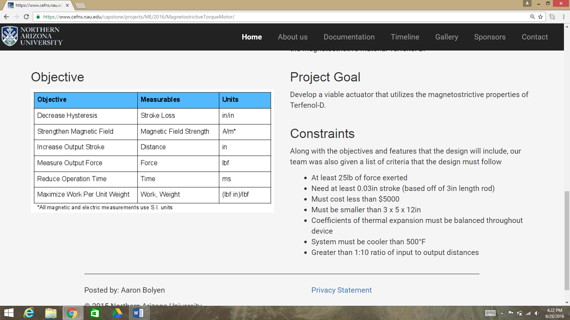

At the end of the year, the Capstone team had designed and built a prototype, seen in Figures 1 and 2, that proved that Terfenol-D could be used in actuators for driving pneumatic devices such as torque motors. As well as a Terfenol-D-driven actuator, the team produced a hydraulic stroke amplifier by way of a hydraulic intensifier. Using brake fluid, the team was able to amplify an output stroke of 10:1 using differential piston areas [1].

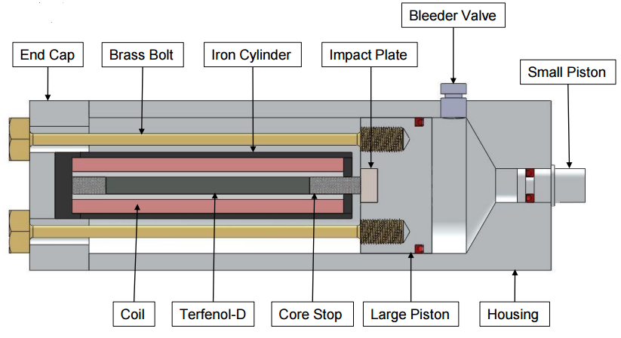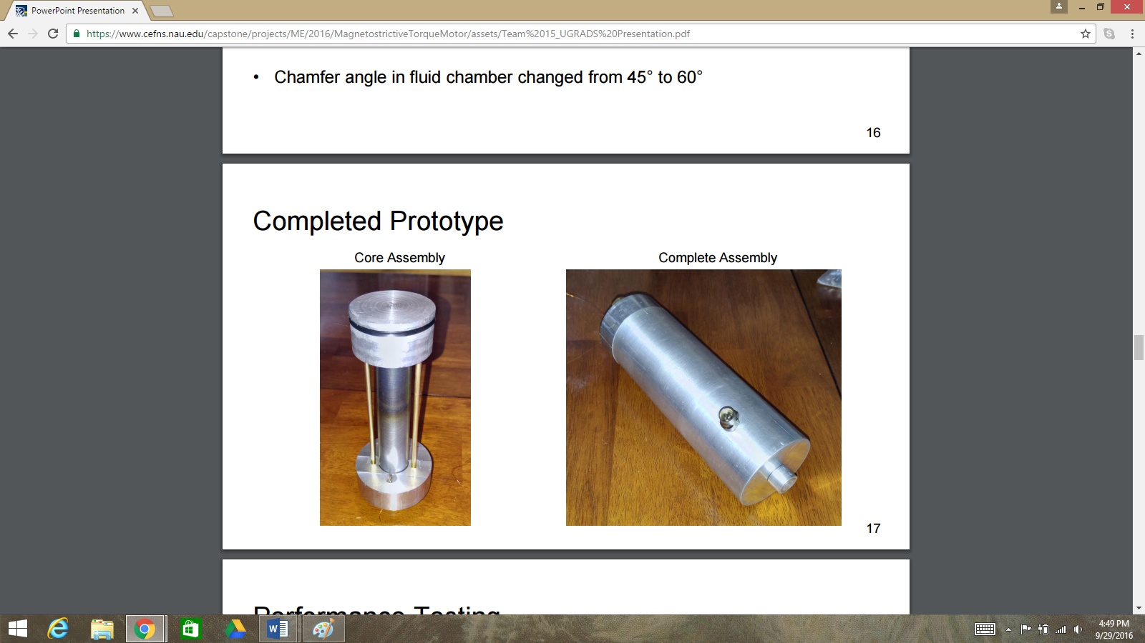
Figure 1: Final Prototype CAD Section View [2] Figure 2: Final Prototype Core Assembly [2]

While the proof-of-concept test was successful, the use of DOT-3 brake fluid was not practical for real-world use due to the expansion of the fluid as temperature increases. The effect on device output due to bulk thermal expansion of the hydraulic fluid would nullify the effect of the Terfenol-D expansion [1]. However, the team suggested that a powder with sufficiently small particles might provide a practical medium to perform the same function as the brake fluid. In the following subsections, the original system structure and operation leading into the beginning of our project are described more in-depth.

1.3.1 Original System Structure
Below in Figure 3 is the exploded view of all the components of the magnetostrictive actuator. The Terfenol-D rod is fitted with the iron core stops fitted on both sides of it. The Terfenol-D rod is then put inside of the copper wire solenoid which fits inside of the iron cylinder. The iron cylinder sits on the aluminum endcap and the pre stressed bolts are put into place around the core setup. The Terfenol-D core is pre-stressed by bolting the large piston into the core setup, and the entire setup is placed into the actuator housing. The bleeder valve is then placed and the hydraulic chamber is filled and made airtight by placing the small piston on the device.
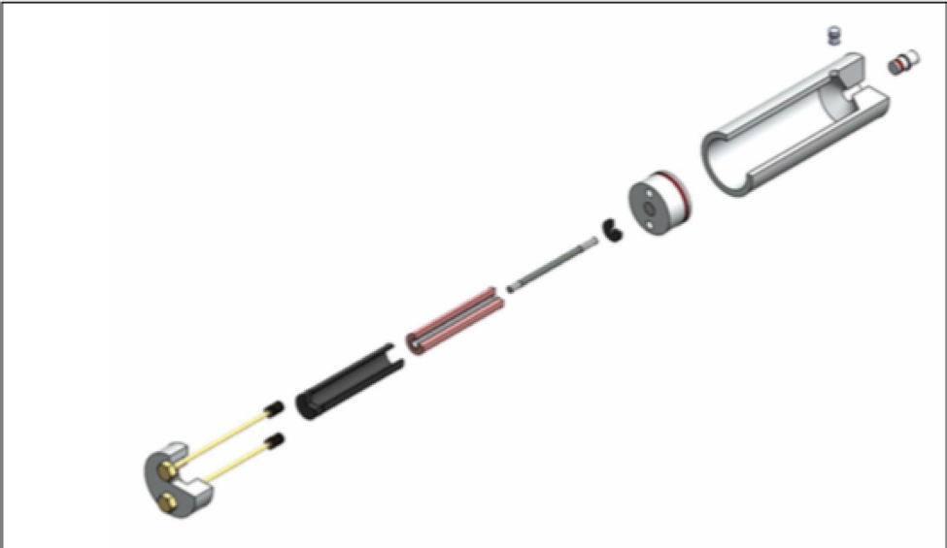
Figure 3: Exploded view of actuator [2]

As seen in Figure 4 last year's Capstone group created the housing out of aluminum. This holds all of the components of the actuator inside.

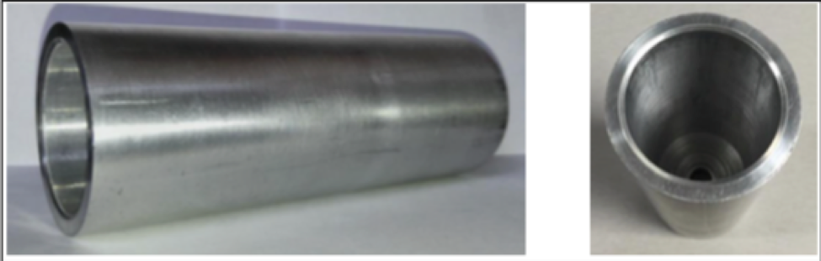
Figure 4: Aluminum housing outer view (left) and inner view (right) [2]

The large piston shown in Figure 5 fits into the fluid chamber at one end and the small piston fits into the other end.

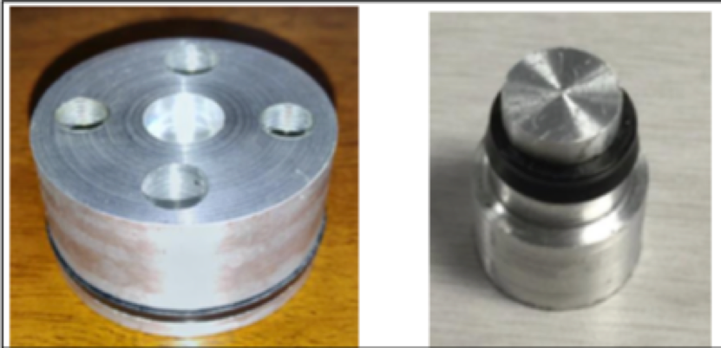
Figure 5: Large aluminum piston (left) and small aluminum piston (right) [2]

Figure 6 shows the steel impact plate. This is intended to keep the aluminum from deforming.

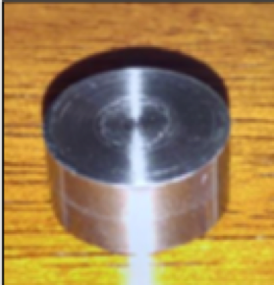
Figure 6: Steel impact plate [2]

Figure 7 shows a 4 inch iron cylinder that will hold the solenoid. The end cap was heat fitted in and is displayed in Figure 8.

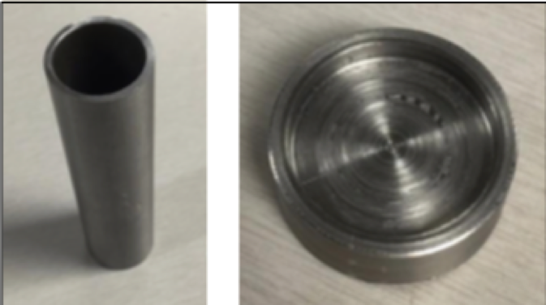
Figure 7: Iron solenoid casing (left) and iron end cap (right)[2]

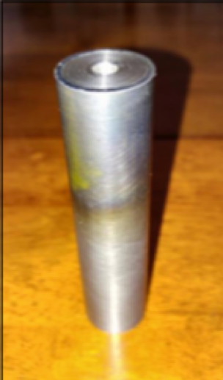
Figure 8: Front iron end cap heat-fitted in solenoid casing [2]

Figure 9 shows the iron core stops which communicate the elongation of the terfenol D to the large piston, compress the prestressed bolts, and complete the magnetic circuit.

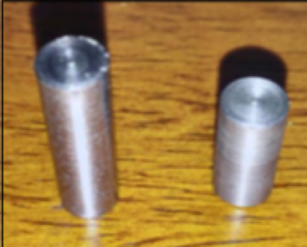
Figure 9: Iron core stops [2]

Figure 10 shows the aluminum endcap used for the housing of the actuator. The brass pre-stressed bolts shown in Figure 11 go through the holes in the aluminum end cap.

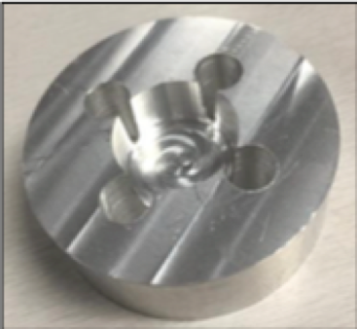
Figure 10: Aluminum endcap [2]

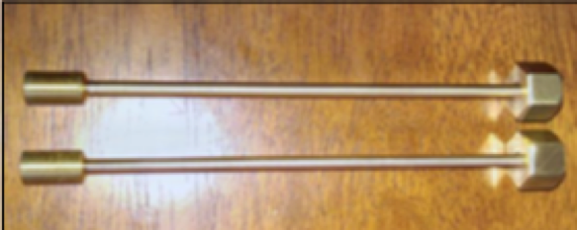
Figure 11: Brass pre-stressed bolts [2]

All of the components assembled prior being placed inside the fluid chamber is shown in the left of Figure 12. The entire assembly is shown on the right.

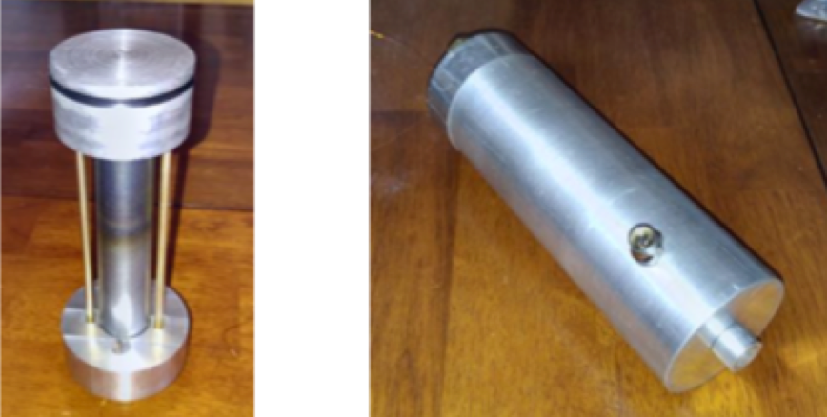
Figure 12: Inner core assembly (left) and full assembly (right) [2]

Displayed in Table 2 is the completed bill of materials for 2015-16 capstone team. The team had a budget of $5,000, but ultimately spent less than $1,700.

Table 2: Bill of materials
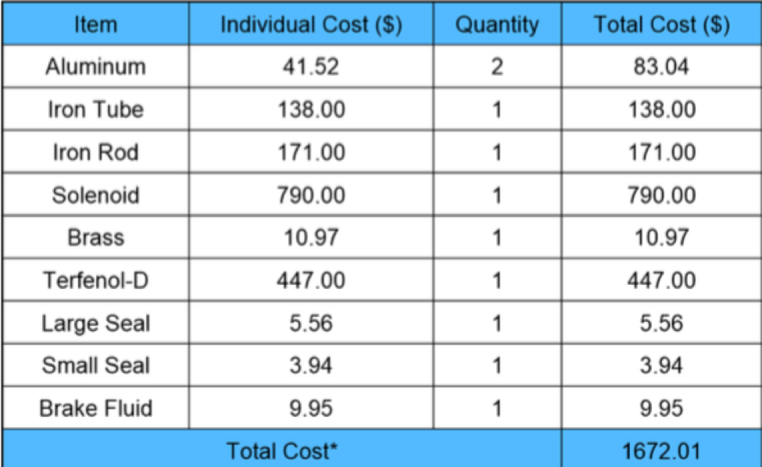

By deconstructing the original system into its individual parts, we were able to analyze how each component contributed to the overall function of the actuator, described in the following sections.

1.3.2 Original System Operation
The operation of the original actuator included many components, the most important being the magnetostrictive material Terfenol-D. Terfenol-D has the largest magnetostriction of any known material, on the order of 100 times greater than other magnetostrictive materials. This means it converts magnetic energy into mechanical energy most efficiently. The rod used was 4 inches long with a diameter of ¼ inch. As shown above, the Terfenol-D was seated between a solenoid such that when current and voltage were applied to the solenoid it would create a magnetic field. The coil consists of magnetic wire with over 1200-1300 turns and a 12V power supply to produce a magnetic field. The magnetic flux created by the magnetic field had a magnitude of 30 mT and was produced by a 2A current running through the solenoid. In order to power the solenoid and in turn actuate the Terfenol-D, a standard wall outlet was used operating at 120VAC.

After all materials and components were chosen and tested the final design was manufactured and built. This design can be seen in Figure 1. When a current is applied to the coils, the Terfenol-D elongates creating an axial force on a plate located on the larger piston that drives the fluid amplifier. This force created by the Terfenol-D and the hydraulic amplifier is then output by the small piston. The actuator developed by the 2015-2016 Honeywell Capstone produced 30 lb. output force, 0.04 inch output stroke, 1:16 hydraulic piston ratio, and had final dimensions of 3x5x12 in^3.

1.3.3 Original System Performance
In order to assess the performance of the original actuator it is important to understand the previous team’s design objectives and constraints. The design objectives can be seen above in Table 1. The design constraints are as follows:

- At least 25 lb of force exerted
- Need at least 0.03in stroke (based off of 3in length rod)
- Must cost less than $5000
- Must be smaller than 3 x 5 x 12in
- Coefficients of thermal expansion must be balanced throughout device
- System must be cooler than 500°F
- Greater than 1:10 ratio of input to output distances

The most important constraints for us to consider in order to evaluate the system performance are the force exerted by the actuator, elongation to stroke ratio, and system thermal requirements. All components were tested individually before the actuator was assembled. Testing included solenoid electrical testing, solenoid magnetic field generation, ANSYS thermal testing, and stroke output testing. The results of these tests clearly demonstrate the system performance parameters.

Solenoid Electrical Testing:
The 2015-2016 Capstone team calculated electrical values based on the use of a wall outlet power source operating at 120VAC and 94 ohms, with 1.2 amps through the solenoid to generate the magnetic field. Based on the results of the previous groups tests, the actual operating parameters are 125VAC from the wall outlet, 96 ohm resistance through the solenoid, and 0.72 amps of current running through the solenoid. While the voltage and resistance were similar to the calculated values, the current was nearly half of the expected value. The 0.48 amp difference in the current was caused by impedance and localized currents in the solenoid, as the values calculated did not account for AC electrical losses or the effect of resistance increasing with temperature.

Solenoid Magnetic Field Generation:
The magnetic field generated by the solenoid was measured where the Terfenol-D would be placed. The calculations gave a result of 107.5mT minimum magnetic field, but measurements returned a magnetic field of 153mT. The difference between the calculated and measured values was expected. The iron casing and core used to complete the magnetic circuit concentrated the magnetic field, thus making the calculated value a minimum value and the measured value acceptable.

ANSYS Thermal Testing:
In order to estimate the maximum temperature reached within the actuator, the previous Capstone team modeled the system in ANSYS. This simulation showed that the maximum temperature achieved by the solenoid given was 106℃, within the acceptable range stated by the constraints given to the team by Honeywell. In order to keep the system below the given temperature constraint, an aluminum endcap was used as a heat sink in order to draw the heat away from key components such as the coils, Terfenol-D, and hydraulic amplifier.

Stroke Output Testing
To test the stroke output, 3 tests were run. Each test was performed using the 125V AC power supply from the wall outlet and a digital multimeter indicator accurate to 1 micrometer. Table 3 displays the results of each test. In the first test, no loads were applied, but a magnetic field was applied to the Terfenol-D core to measure the pure elongation without the bolts causing pre-stress. In the second test a load was applied by applying a magnetic field to the Terfenol-D core and the stroke was then measured with the pre-stressed bolts and large piston assembled. The third and final test included all components of the device and showed the total device output.

Table 3: Stroke Output Testing Results
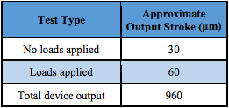

1.3.4 Original System Deficiencies
The 2015-2016 Capstone team successfully met the customer requirements of developing a viable actuator that incorporates the material properties of Terfenol-D. However, the team used brake fluid for their incompressible fluid in the fluid chamber which does not have a coefficient of thermal expansion that matches that of any possible body material’s. This problem is now the focus of our project: to find a fluid or powder that will replace the brake fluid and provide an output amplification of at least 10:1. Another aspect last year's team would have changed is to have used direct current (DC) to the solenoid rather than alternating current. The DC would allow for a larger magnetic field to be applied. With a larger magnetic flow, more elongation would occur which translates into a larger stroke being applied.

2 REQUIREMENTS
After analyzing the project as well as communicating with Honeywell’s project leads, seven customer requirements were created. These customer requirements were ranked on a 1 to 5 scale with 5 being most important to the project. The customer requirements, seen in the right side of the House of Quality (HoQ) were then used to find the engineering requirements displayed in the vertical columns of the HoQ. As the project progresses further, the engineering requirements will be updated with more accurate Targets and Tolerances. The following section discusses each customer need with an explanation of each need’s respective weighting.

2.1 Customer Requirements (CRs)
Upon reading the problem statement, the first emphasized CR was that the powder or material inside of the actuator behaves as a semi-fluid. This customer requirement is reliant on small particle size and was given a maximum importance score of 5. The next customer requirement of maximum importance is practical application for each chosen material, meaning that each chosen material should be used only to its particular strengths and capabilities. The last customer requirement with a rating of 5 is matching the thermal expansion for the body of the actuator and the amplifier powder within. This requirement is extremely impactful on the project: without matching coefficients of expansion the actuator will not function as needed when subjected to temperature change. The next highest rated requirement with a rating of 4.6 is to maximize output amplification, as the objective of the actuator is to increase force from input to output by a factor of 10. The demonstrator should also retract to original position after the force is removed producing a smooth hysteresis curve, and was given a 4.4 weighting. A sealing mechanism to prevent leakage of the material was also rated highly and given an overall importance factor of 4. The last customer requirement is to minimize both fatigue and failure. Because this was not emphasized by Honeywell during the Skype meeting, it was given an importance rating of 3.4.

2.5 House of Quality (HoQ)
Following the approval from Honeywell’s clients on our generated CRs, a HoQ was constructed (Figure 13) displaying the customer needs, their associated weightings, the engineering requirements derived from the customer needs, and the correlation between the engineering requirements and customer needs. The correlation between the engineering requirements and customer needs were ranked on a 1, 3, 5 scale, with a 5 being a strong correlation, a 3 being a moderate correlation, and a 1 being no correlation. These values identify which requirements need to be the focus of our design over all others.

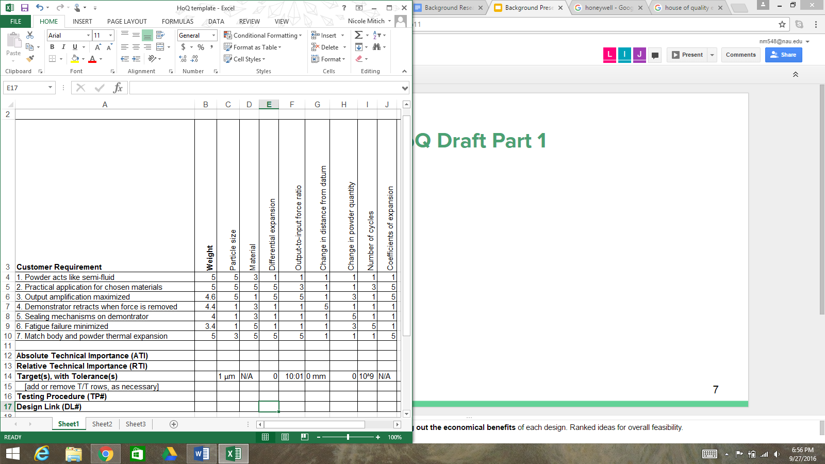
Figure 13: HoQ Draft

3 EXISTING DESIGNS

3.1 Design Research
The first step in our design research was to investigate the original actuator designed by the 2015-2016 Honeywell capstone team. In doing so, we reviewed their website, analyzed their reports, and interviewed the previous client contact, Michael Roper. With no other magnetostrictive actuators currently on the market, research on other similar products is extremely limited. Particularly, the use of powders to act as semi-fluids within actuators is previously untested. However, this year’s team will focus on investigating powder materials with comparable thermal qualities to steel or other solid materials via web searches and literature reviews. This will benefit not only the powder amplifier, but the housing and overall performance of the actuator.

3.2 System Level

3.2.1 Existing Design #1: Hydraulic Actuators

Hydraulic actuators consist of a cylinder or fluid motor which converts a course of hydraulic power to produce a mechanical output. The produced mechanical motion is produced by the use of a piston and can result in either linear, rotary or oscillatory motion [3]. Liquids have the ability to exert a high force which overcomes the fact that they take longer to gain speed and power due to its incompressibility. However, their inability to gain speed results in limited acceleration potential. Hydraulic actuators can be operated manually or through a hydraulic pump. In aircraft equipment, hydraulic actuators operate a range of equipment, including landing gear, wheel brakes, and flight control surfaces [4]. Overall, hydraulic actuators are ideal for high-force applications, which is a beneficial characteristic to be used with a material such as Terfenol-D.

3.2.2 Existing Design #2: Pneumatic Actuators
Pneumatic actuators produce a usable form of energy from using pressurized air. They are beneficial due to their simplicity and can be used in extreme temperatures. In summary, a pneumatic actuator utilizes a cylinder and piston to use compressed air as a working fluid to produce the desired energy output. [5]. However, it does not transmit power as easily as a hydraulic actuator due to the liquid media in hydraulics and is not suited for certain applications due to size limitations [5]. Aircraft systems use pneumatic actuators in pressurizing the cabin and wing anti-ice systems. They are desirable for aircraft equipment due to the reduced weight of not needing a fluid media to operate [6].

3.2.3 Existing Design #3: Magnetic Actuators
Magnetic actuators are driven by the properties of a magnetic field, called a solenoid, to convert electrical energy into mechanical energy. The main benefit of using a magnetic field over an electric field is the ability for higher energy density to result in an increased output of energy [7]. Magnetic actuators can be designed for different outputs by changing the geometry, such as disks, lungers, and cones. They have the capability to produce a high magnitude of usable energy from a small input [8]. The use of magnetic actuators in aviation equipment include either focus or shutter mechanisms to produce a rotary motion for high-torque applications [9]. In relation to our project, the existing Honeywell amplifier operates in accordance to these basic principles of a magnetic actuator.

3.3 Subsystem Level
Because our project is a subsystem in itself, the amplification aspect of the magnetostrictive torque motor can be deconstructed into its three major components of focus: the titanium housing, semi-fluid-behaving powder, and silicone rubber seal, gathered from the illustration provided in Figure 14. Because the actuator has already been prototyped by the 2015-2016 Capstone group and we will not be handling any magnetostrictive materials, our primary focus is finding a suitable powder to match the thermal coefficient of expansion of the housing, and implementing a seal to prevent the leaking of powder during stroke, as discussed in the previous sections. The aforementioned components described in detail in Sections 3.3.1-3.

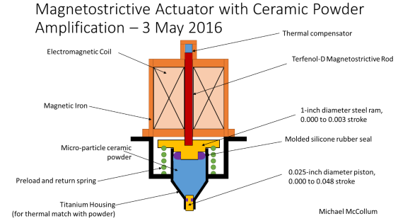
Figure 14: Provided Illustration of Subsystem [1]

3.3.1 Subsystem #1: Housing
The housing for our powder amplifier is crucial to the operation of the actuator. Because it is the exterior to the system, we need it to be able to withstand large stresses and a high number of cycles. However, we also need it to match the coefficient of thermal expansion of our selected powder semi-fluid in order for the magnetostrictive force to be amplified instead of swamped during temperature increase or decrease. As such, several housing methods were researched, the results of which can be seen in the following 3 subsections.

3.3.1.1 Existing Design #1: Protective Housing for a Ceramic Actuator
The first housing application describes housing to protect electro-active ceramic actuators. Ceramic actuators are manufactured from multilayer material and sintered at high temperatures into their final shape [10]. While their construction is well-known, their applicability is limited due to the brittleness of ceramics. However, a strong outer shell reduces the sensitivity of ceramic actuators against sudden impacts, which may be applicable to our design if we can find a ceramic powder for amplification. We could then utilize the existing titanium housing and implement an inner ceramic shell to match the coefficient of thermal expansion of a potential ceramic powder.

3.3.1.2 Existing Design #2: DACS actuator
The direct acoustic cochlear simulation (DACS) actuator is a US Patent that describes a compensation system for an implantable actuator. This implantable medical device uses an actuator which directly stimulates the inner ear fluid by simulating the operation of a normally functioning middle ear [11]. As a part of its design, it contains a sealed titanium housing containing a driving arrangement for the actuator which is relatable to our original system in function and appearance. Although it has a pressure system external to the housing, it performs the same function on a smaller scale. If we find a powder with a coefficient of thermal expansion matching that of the original titanium housing, we may be able to use this system for guidance.

3.3.1.3 Existing Design #3: El-o-matic Actuator with CSR Coating
The El-o-matic actuator is an actuator featuring a hard, anodized aluminum shell with stainless steel fasteners [12], similar to that of the original system’s titanium housing. However, unlike the original system, it has a ceramic filled fluoropolymer epoxy resin coating on the interior of the actuator. This gives the actuator added corrosion resistance, with 40% of the resin inserted into the aluminum housing and the remaining 60% staying on the surface of the interior. Though our actuator will not be in contact with chemicals requiring the added corrosion-resistance, the coating may be able to match the coefficient of thermal expansion for our desired powder, generating a viable actuator system for Honeywell’s avionics.

3.3.2 Subsystem #2: Powder Semi-fluid

3.3.2.1 Existing Design #1: Econostar ES-106 Cenospheres
As a suggestion by the 2015-2016 Capstone group, cenospheres were researched for application in the powder amplifier. Cenospheres are lightweight, inert, hollow spheres filled with air or gas and made mostly of silica and aluminum oxide. Econostar ES-106 cenospheres are under 106 micrometers in size and have a bulk density of 0.32 to 0.45 g/cc [13]. Its crush strength for 90% survival is 1600 to 3200 psi, and it possesses a coefficient of thermal expansion in the range of 13.1×10⁻⁶-11×10⁻⁶/°C, which is lower than that of pure aluminum [13]. If we can match its coefficient of thermal expansion, this may be a feasible product to incorporate as our powder amplifier.

3.3.2.2 Existing Design #2: Semi-Solid Metallic Alloys
Semi-Solid attributes are produced by breaking down metallic alloys, specifically aluminum into their base microstructure [14]. Such granular models have previously been analyzed using finite element analysis and have proven to accurately model liquid flows. Aluminum also has a fractional thermal expansion per degree of approximately 24×10⁻⁶/°C. This thermal coefficient of expansion is comparable to other metals which could replace titanium as the actuator casing.

3.3.2.3 Existing Design #3: Silica Aerogel
Silica Aerogel is a material with high specific surface area, high porosity, low density, low dielectric constant and excellent heat insulation properties [15]. These gels are translucent in appearance, and have applications in insulation on the Mars Rover, hypervelocity particle capture, radiation particle counters, and remediating oil from water [15]. Future applications include nanotechnologies which heavily rely on nano-porosity, load bearing abilities, and convective inhibition. Its coefficient of thermal expansion was found to be 2 ppm/C° at 20 - 80°C [15]. Because of these properties, we may be able to implement silica aerogel to amplify our actuator output stroke.

3.3.3 Subsystem #3: Silicone Rubber Seal
Silicone rubber is a synthetic elastomer that is non-reactive, stable, and resistant to extreme environments and temperatures, making it a perfect product to seal our amplifying powder. It is widely used throughout the automotive and aircraft industries, including applications in rotary and shaft seals, o-rings, and syringe pistons.

3.3.3.1 Existing Design #1: GAMMA Seal
Rotary and shaft seals are used in applications with rotating parts to keep lubrication in while keeping unwanted debris out. By applying these seals to shafts, it improves the shaft and gear box’s lives and long term performance. In particular, the GAMMA Seal excludes contamination, moisture and grease. It consists of an elastomer sealing lip contained in a metal carrier allowing it to effectively cope with arduous static and dynamic conditions in mobile hydraulics and power transmission applications [16]. In our application, this would be critical to keeping the powder contained, preventing leaking over time, and minimizing fatigue failure. Additionally, the seals are capable of withstanding both high and low gear box operating temperatures, making it especially practical for our need of a real-world actuator.

3.3.3.2 Existing Design #2: Prepol O-Rings
Prepol pre-formed o-rings are used to assist assembly and prevent unnecessary stresses being placed upon the seals [17]. As such, they can be implemented to extend the life of a part, which correlates to our minimization of fatigue failure for the amplifier. Furthermore, as it is constructed of silicone rubber, it has performance characteristics that meet high temperature, high pressure and aggressive chemical applications [17]. These characteristics are essential to our amplifier’s performance, as the actuator will be operating between temperatures of -65 F and 250 F.

3.3.3.3 Existing Design #3: Optimum® SmoothFlow™ pistons
Optimum SmoothFlow syringe pistons are constructed with channels to prevent the trapping of air, but are also designed to reduce the shearing of fluid [18]. Additionally, its precision edges wipe the syringe interior during stroke to eliminate liquid waste and residue. They work in correlation with the barrel to promote uniform dispensing force and prevent fluid leaking. This exact fit may be utilized in our solution when designing our seal. Not only do we want to prevent powder leaking, but we also want to prevent air entrapment and ensure uniform pressure forces.

3.3.4 Functional Decomposition
To clearly represent each subsystem within our overall powder amplifier system, we constructed a functional model that depicts the important functions that require attention. Because our system appears to be uncomplicated, a functional model clearly decomposes our seemingly simple system and gives us specific functions that we need to find solutions for. Figure 15 shows the functional model for our powder amplifier.

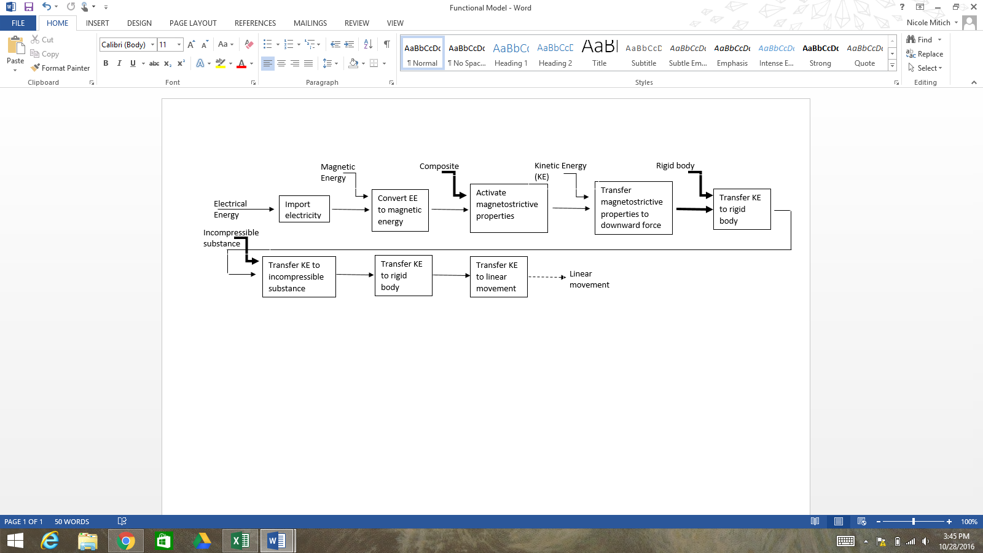
Figure 15: Powder Amplifier Functional Model

Shown in the functional model are our key functions and flows, each category of which is depicted using a different line. Any materials into, out of, or through our system are indicated with a bold line; any energies are signified with a solid line; and any signals are expressed using a dashed line. The main flows of energy moving through our system are electrical, magnetic and kinetic energy. The initial import of electrical energy activates the solenoid, producing magnetic energy and elongates the Terfenol-D rod. The elongation produced by the Terfenol-D rod then generates kinetic energy which moves through the system with a series of linear piston movements.

4 DESIGNS CONSIDERED
With a clear understanding of our subsystems, we began our concept generation by implementing the 6-3-5 method as well as a group brainstorming session. By using these approaches, we ultimately produced over 25 design concepts. While some of these concepts were clearly not feasible, we could intuitively reduce our number of concepts to 10, each of which are described in detail with their corresponding advantages and disadvantages below.

4.1 Design #1: Bio-Inspired Mechanical Lever System
As proposed by Dr. Trevas to our team during a staff meeting, we took an entirely different approach to the problem. Instead of considering a change of materials for the amplifier, we considered a mechanical lever system to replace any powder or fluid in our system. At first proposal, this approach was hard for our group to fully grasp, as it was outside the initial scope of our project. In order to get a better understanding of how a mechanical system could be implemented, we researched some applications of such a design in nature. Figure 16 is one of our most comprehensive results from our research: the human foot-ankle combination.
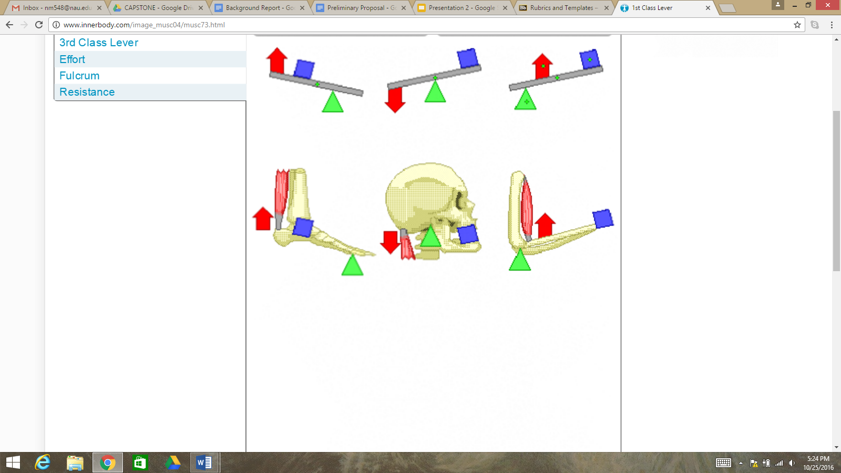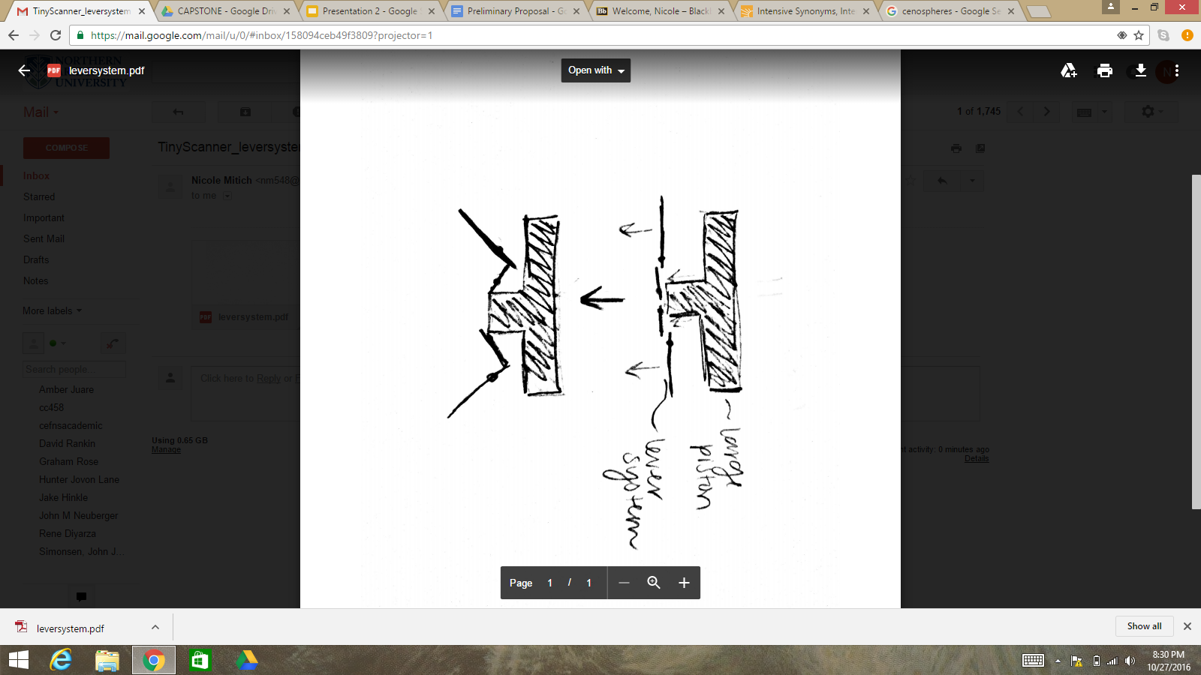
Figure 16: Human Application of a Lever System [19] Figure 17: Sketch of Lever System

After visualizing such a system in this manner, we were able to sketch a preliminary design of the lever system we were envisioning, seen in Figure 17. By removing the need for a “fluid” amplifier, we reduced the number of customer needs we have to consider, including the implementation of a sealing mechanism and the necessity to match the coefficients of thermal expansion of the fluid and the housing. Despite these possible advantages, the actual feasibility of a mechanical lever system replacement would require thorough analysis and testing, each of which would require time and energy and may not result in a plausible solution.

4.2 Design #2: Inner Housing Thermal Coating

Since one of the main customer requirements is to match the thermal coefficients of expansion, our team is considering changing different aspects of the amplifier chamfer. Figure 18 shows a simplified sketch of the internal material on the housing.
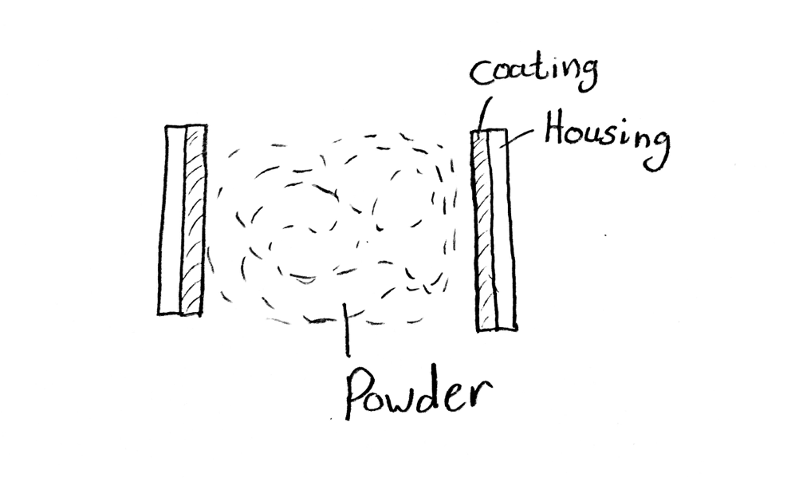

Figure 18: Inner Housing Thermal Coating

Applying a material coating that has the same coefficients of expansion as the fluid would allow the materials to expand and contract at the same rate, while maintaining the integrity and strength of the external housing. This would be a change to the housing system and could allow us to use a variety of powders with a larger range of coefficients of expansion within the amplifier. A disadvantage of applying a coating is that it could be difficult to find, apply and test a suitable material. Furthermore, once the material is applied we would have to test to ensure that the coating would stay attached to the housing for the lifetime of the device.

4.3 Design #3: Cenospheres

Suggested as a design solution from the 2015-2016 Honeywell Capstone team, cenospheres, seen in Figure 19, are microscopic, hollow, inert ceramic spheres that look like a powder and primarily consist of silica and alumina.

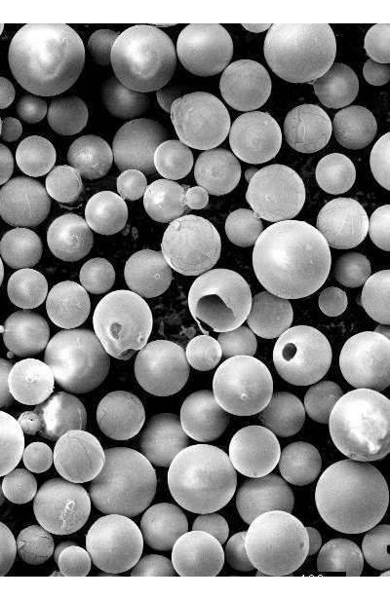
Figure 19: Microscopic Image of Cenospheres [20]

These spheres are self-lubricating and may be a beneficial addition to the design if they are proven to act as an incompressible fluid. If these spheres do act as such, they would be able to operate in the large temperature range that airplanes are subjected to without expanding like the current application of DOT brake fluid. However, despite this advantage, there is not much research available on cenospheres. Because of this, we may not be able to find definitive proof of its feasibility as a concept unless we purchase them and run tests ourselves. This could prove to be costly, time-consuming, and ultimately unuseful for our project.

4.4 Design #4: Powdered Metal
Next, our team considered utilizing a powdered metal in place of the brake fluid, similar to the concept of the cenospheres (Section 4.3 Design #3), primarily to match the coefficients of thermal expansions of the housing and the fluid-like material in the amplifier. Matching these coefficients is a top requirement for our project in regards to both the customer and engineering requirements, and the ability to satisfy this requirement is a powerful advantage to this design concept. A powdered metal, such as steel or titanium, would have a greater chance of matching the coefficient of expansion to the housing as opposed to another material type since the housing is largely metal. Overall, this design meets several of our more important customer requirements, such as amplifying the output amplification if the powdered metal behaves as a fluid, as well as reducing the failure fatigue due to the extensive life of metal compounds over numerous cycles. The technical ability to meet all engineering requirements will be determined following further analysis, such as the minimization of hysteresis and the appropriateness of the particle size.

Alternatively, there are several cons to this design idea. The behavior of powdered metal is unknown in regards to its ability to act as a semi-fluid and the manufacturing process of creating metal particles of appropriate size to be applicable in the amplifier. The bulk thermal coefficient of expansion is another variable our team would need to test within the housing, as the difference in expansion between a powder and solid of the same metal. There is also the issue of hysteresis, due to the addition of another metal material interacting with metal housing and other metal components within the amplifier and actuator. For example, consider the application of a metal-on-metal knee replacement within the body. The amount of friction and degradation of the metal over extended cycling would drastically reduce the lifetime and quality of the product. A similar metal-on-metal concept may prove unusable in the existing amplifier.

4.5 Design #5: Insulated, Layered Housing

Although one of our main design objectives was to match the coefficients of thermal expansion of the outer housing material and the amplifying fluid, we struggled to find housing and fluid materials with similar coefficients of thermal expansion. In order to compensate for the difference in the coefficients of thermal expansion for different materials we had the idea to create a difference in the temperature to which each material was exposed. This can be done by the implementation of an insulated layer in between the outer housing and the amplifier inside, shown in Figure 20.

The actuator is exposed to a wide range of temperatures where conduction and convection affect the contents of the actuator. The heat delivered by convection to the outer housing is transferred by conduction to the amplifier inside. In order to reduce the transfer of heat, a barrier or insulator can be implemented. By creating this temperature difference, the ratio of thermal coefficients to the temperatures each material is exposed to can be matched. This means that two separate materials can be used that have differing coefficients of thermal expansion yet still expand or contract by the same percentage. However, adding an additional layer could potentially increase the overall volume of the actuator which could render the actuator not useful for practical application.

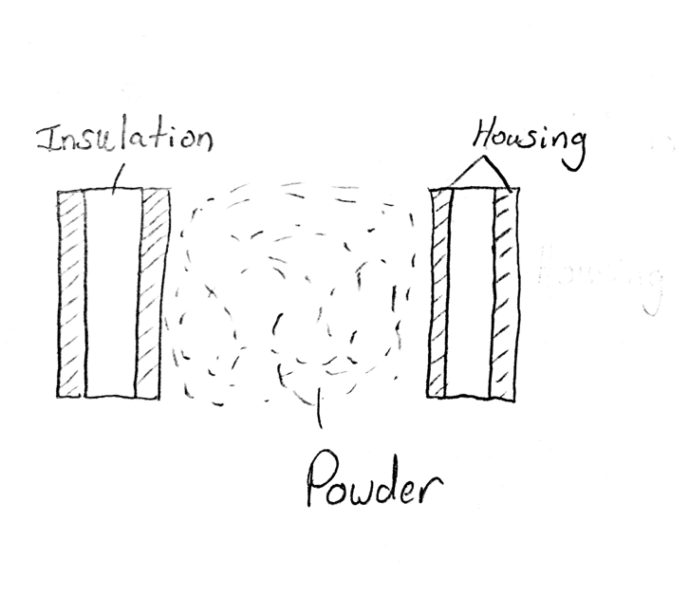
Figure 20: Insulated Housing Sketch

4.6 Design #6: Ceramic Housing

The existing housing of the actuator is made of titanium, which has a much different thermal coefficient of expansion than the current liquid medium used in the amplifier, resulting in a non-practical design. The 2015-2016 Honeywell Capstone team suggested the use of a ceramic powder to act as a fluid material in the amplifier (Section 4.3 Design #3), which resulted in a proposed design idea by our team of using said ceramic powder conjunctively with a housing of similar material. If the existing titanium housing were to be replaced with a ceramic material, the need to match coefficients of expansion would be satisfied. However, altering the existing design of the housing of the actuator would drastically change the integrity of the original design. Altering the material of the housing would require extensive redesign and analysis to determine the feasibility of a ceramic actuator in practical applications and may be an entirely new project in itself. Due to our customer requirements and corresponding engineering requirements that are centered around modifying the amplifier fluid and not the housing, the current House of Quality is not entirely applicable to this design concept. In addition, this design idea solely relies on the successful application of cenospheres as replacement for the brake fluid in the amplifier, which is yet to be determined.

4.7 Design #7: Hourglass Chamfer

Implementing an hourglass shaped chamfer, Figure 21, in the fluid chamber of the amplifier, as opposed to a linear chamfer, would allow the selected powder to flow more smoothly and ideally reduce the effects of hysteresis. This could also be beneficial to allow the powder to flow more like a fluid. However, the team would have to test how the fluid-like material would act in different temperature ranges operating under a different geometry within the amplifier. This would also complicate the machining of the chamfer, since creating a non linear chamfer would be more difficult to machine than a linear chamfer.
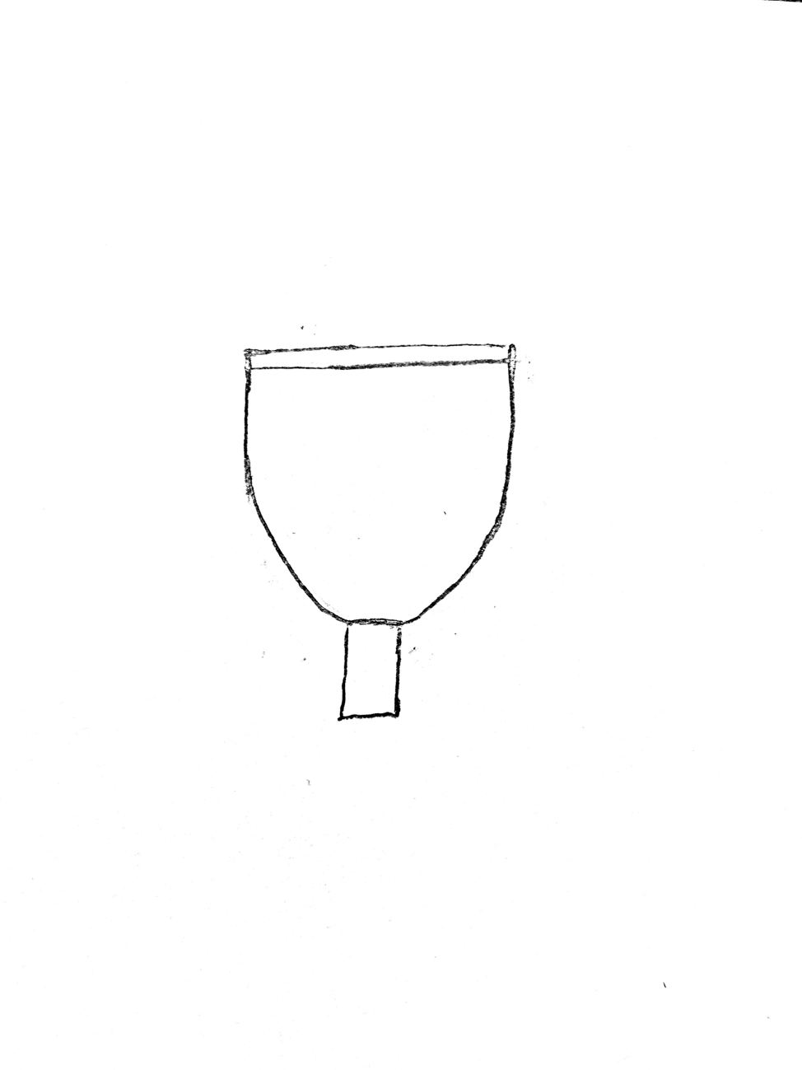
Figure 21: Hourglass Chamfer

4.8 Design #8: Heat Sinks

Another design concept that makes mechanical additions to the actuator is the introduction of heat sinks to the outer housing. Heat sinks draw heat that exists in a material by creating a large surface area in order to dissipate heat and can be seen in Figure 22. This mechanism will decrease the temperature range constraint allowing us to select materials with increased coefficients of thermal expansion. A disadvantage of implementing heat sinks could be an increased volume due to the fact that usually heat sinks consists of extended fins protruding from the heated surface. Another disadvantage would be that it does not create a temperature difference between the inner and outer housing. Although it does decrease our range of temperatures, the materials used must still have matching coefficients of expansion.

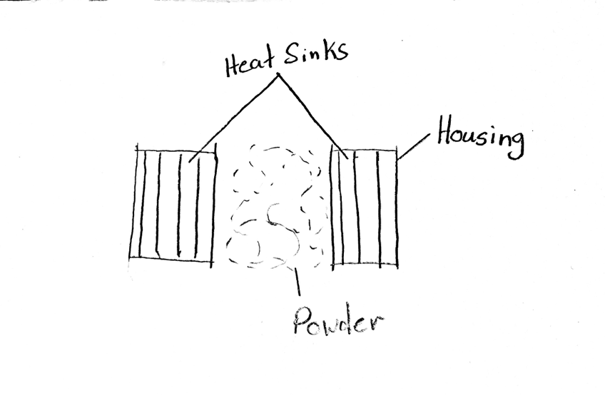
Figure 22: Heat Sinks

4.9 Design #9: Zirconia
Zirconia is a ceramic substance with a thermal coefficient of expansion of approximately 10.8×10−6 degrees Celsius. In particular, Partially Stabilized ZrO2, which is also known as Y2O3, has the ability to withstand high temperature and stress. This ceramic is being explored as a possible material for the actuator housing. The unique attributes of Zirconia, including its high thermal resistance and insulation qualities, have the ability to expand our material selection process. With Zirconia’s insulation factor being so high, the possible range of materials with varying thermal coefficients of expansion can be enlarged. This range expansion would give our team the ability to choose from a larger pool of possible materials. Our group is also doing research into semi-solid Zirconia as our selected powder medium. Such a material should work well inside of our current actuator design, due to its thermal coefficient of expansion being relatively similar to that of many metals.

4.10 Design #10: Cooling System
Our team has done extensive research into possible actuator cooling systems. With an individual cooling system installed inside the actuator, the possible list of medium materials inside the actuator can be expanded due to the reduced need to match the coefficients of thermal expansion. This design also has the ability to lower the maximum temperature that a selected material must have the ability to withstand. However, deciding to design a cooling system into our current actuator would require a complete design overhaul. This overhaul would be costly in terms of both money and time, and would most likely require extensive design testing. One example of a cooling system is that of a laptop. Laptops are cooled through a multitude of ways, including either fans or running cold water throughout the entirety of the system. Importing such a cooling system into our current design would help to decrease the upper thermal limit of our desired actuator medium.

5 DESIGNS SELECTED

5.1 Rationale for Design Selection
Although we intuitively narrowed our number of concepts to a more manageable number, we still had 10 concepts for review. To select a more finite final design, we initially used a Pugh chart, seen in Appendix A at the end of this report. The Pugh chart qualitatively reduced our number of concepts by half by comparing the given concepts to a random datum and our customer needs, giving us only 5 final designs to analyze.

In Appendix A, our final 5 designs are identified by red text, yielding the mechanical lever system, housing coating, layered insulation, cenospheres, and zirconia as our best candidates for project success. We then constructed a decision matrix to help us quantitatively judge our final 5 designs, comparing each design with each of our customer needs, and ranking our designs in order of best satisfier of customer needs to worst. The resulting decision matrix is viewable in Appendix B at the end of this report. This analysis revealed the most theoretically successful contenders of satisfying the project’s customer needs as cenospheres, the lever system, zirconia, and coating and insulation, respectively.

Given a budget of $2,000 and having spent $0 thus far, we will complete a cost analysis of each design concept, and potentially purchase the necessary materials to test the application of each final design - beginning with the most viable (cenospheres) - if our budget permits it. By running individual tests on each concept, we will be able to see first hand how our designs solve each problem, and provide physical results and reasoning to our clients.

5.2 Design Description

After a client meeting following the concept generation process, the team was firmly redirected to focus solely on finding a) if a powder can act like a fluid, b) if the semi-fluid powder can match the coefficient of expansion of the housing, and c) if the semi-fluid powder will generate hysteresis within the actuator. There is no longer any client desire for the team to pursue any concepts that are not powder-based. With this client modification, we each decided to analyze different powder aspects that would lead us to whether or not a powder can act like a fluid. The following subsections provide each team member’s analysis.

5.2.1 Individual Analysis #1: Nanofluid Application

5.2.1.3 Design Concept

Our team’s goal is to replace the brake fluid with a viable medium so that the thermal coefficients of expansion of the fluid in the amplifier and the housing of the actuator match. In addition, the medium must act as a semi-fluid and that there must be no change of volume of the medium out of the stroke amplifier over time. The application of a slurry mixture, where a suspension may be made of a powder in a minimal amount of fluid, would ideally allow a powder to act as a fluid.

The type of slurry to be used in this application is formally known as a nanofluid, where materials contain a suspension of nanometer sized solid particles [21]. The design concept of using a nanofluid, as opposed to a nanoparticle on its own, may be the key to using a powder material as a fluid.

5.2.1.2 Assumptions for Analysis

5.2.1.2.1 Expansion Types

Three different types of thermal expansion can occur within a medium: linear, area, and volumetric. Solid materials experience all three types, while liquid and gas only experience volumetric expansion [22]. For ease of analysis, only volumetric expansion will be analyzed and all provided thermal coefficients of expansion are assumed to be volumetric. Under uniform expansion, the equation for the coefficient of volumetric expansion is β = ΔV / V_{o}ΔT, defined as the change in volume of a solid per unit volume by unit rise in temperature [22].

5.2.1.2.2 Maintain Constant Volume

One of the main engineering requirements of this project is that there will be no change in volume of the medium inside of the amplifier. This will be validated by analyzing another subsystem of the actuator (sealing mechanism). The most common outcome of a liquid and solid under varying temperature is that they both experience volumetric expansion, but at different rates; liquid expands much greater than solids under higher temperatures. The current challenge is to create a mixture where the solid has a lower coefficient of thermal expansion (CTE) than the housing, while using a liquid of greater CTE. This would result in the creation of a nanofluid to equalize the CTE of the amplifier medium to the CTE of the housing. Thus, no net change of volume would occur between the housing and the amplifier nanofluid.

5.2.1.2.3 Coefficient of Thermal Expansion

The primary goal of this project is to successfully match CTEs for both the solid and liquid material throughout the actuator to create a feasible design for use in extreme temperatures, from -65ºF to 250ºF as dictated by Honeywell. The expansion coefficient of the housing, which is primarily titanium, is assumed to be 8.6 x 10⁻⁶ / ºC [23] for this analysis. Hydraulic fluids for use as the amplifier liquid, regardless of quality, generally have a CTE of 5.7-7.6 x 10⁻⁴ / ºC [24], two orders of magnitude higher than solids. The upper limit of the brake fluid currently used in the amplifier, DOT-3, has a CTE value of 7.6 x 10⁻⁴ / ºC [25], and will be used for this analysis. Several solid materials of interest for use as nanoparticles, which are all ceramic mediums, are provided in Section 3 along with their CTEs.

5.2.1.2.4 Negligible Negative Thermal Expansion

The final assumption for this analysis is that all materials analyzed in this study, as well as used in the actuator, experience no negative thermal expansion (NTE). NTE is the contraction of a material when subjected to lower temperatures, the opposite of positive thermal expansion, which we associate with CTE values. According to modern research, NTE does not occur in most materials until a lower temperature point of -150ºC (-238⁰F) is reached [26]. This lower temperature limit is a general assumption for all materials, and a fair assumption for this analysis.

5.2.1.3 Analysis Results

Several nanoparticles have ideal properties to be used in a fluid application for the amplifier for the magnetostrictive actuator, specifically their chemical composition (all ceramics) and their CTEs [27]. These nanoparticles are applicable to this project and are outlined in Table 4. Ideal for the use in the existing amplifier, nanofluids can be used as control elements for a range of heat transfer applications [28]. The following equation is used to find the thermal expansion of a nanofluid for a given solid particle and liquid [21],
(ρβ)_{nf} = (ρβ)_{f} (1 - φ) + (ρβ)_{s} φ (Equation 1)

where ρ = density, β = volumetric thermal expansion coefficient, and φ = solid volume fraction of nanoparticles. Volumetric thermal expansion is dependent on density, hence the variable ρβ is the resulting CTE. The subscripts nf, f, and s correspond to nanofluid, fluid, and solid nanoparticles, respectively. Extended calculations for the value of φ to satisfy the CTE of the housing are provided in Appendix A. Rearranging Equation 1 provides the formula to directly calculate the solid volume fraction,

φ = (ρβ)_{f} - (ρβ)_{nf} (Equation 1.1)
(ρβ)_{f} - (ρβ)_{s}

where (ρβ)_{nf} is set equal to the ρβ value of the titanium housing. Values for appropriate variables, as well as the calculated volume fraction required of the nanoparticles, can be found in Table 4.

Table 4: Materials for Nanofluid Application
Material  (nanoparticle) | Coefficient of Thermal Expansion ( ºC⁻¹) | Density  (g/cm³) | Solid Volume Fraction | Unit Price  ($ / g)
Silicon Nitride [27, 29, 32] | 2.8 | 3.2 | 0.9647 | $3.38
Aluminum Nitride [27, 29, 32] | 4.6 | 3.26 | 0.9717 | $4.40
Synthetic Diamond [27, 30] | 1.1 | 3.05-3.3 | 0.9585 | $34.80

As shown, all three nanoparticles are capable of being used in a nanofluid under the specific constraints of matching the CTE of the housing and continuing to use. For the three nanoparticles analyzed, the solid volume fractions are highly comparable at 0.96 + 0.01.

Full calculations and assumptions for this design concept can be found in Appendix C. It is important to note that brake fluid is not is the optimal liquid for a nanofluid application because of its large CTE in comparison to metal and ceramic materials. However, this analysis shows that using brake fluid, a non-favorable liquid, can still contribute to a feasible design concept within the amplifier if used in a nanofluid.

5.2.2 Individual Analysis #2: Effect of Intermolecular Forces on Powder Particles

Powder fluidization depends on various variables: shape, temperature, Knudsen number, and, arguably most importantly, size [33]. For clarification, while particles like sand do not appear to behave like a fluid up close, from a distance, the sand dunes behave with fluidic motion; that is, the individual particles appear to move as a continuum as discussed in fluid mechanics [34]. Using this point of view as a basis for our project, if a powder can behave like an incompressible fluid, the particles would have to be smaller rather than larger in size, with the necessary average size still to be determined. At this scale, the fluidization requires the balancing of fluid-dynamic forces and interparticle forces. Thus, the influence of Van der Waals and electrostatic forces becomes prevalent, affecting particle aggregation and conglomeration [35].

Van der Waals forces are used to describe the attractive forces experienced between electrically neutral particles, as illustrated in Figure 23.

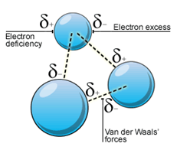
Figure 23: Illustration of Van der Waals Force [36]

As particle size increases (to a critical radius), the effect of Van der Waals forces increases among particles, eventually attracting particles into clumps, disrupting the fluidic motion of the powder. This can be mathematically modeled using Equation 2.

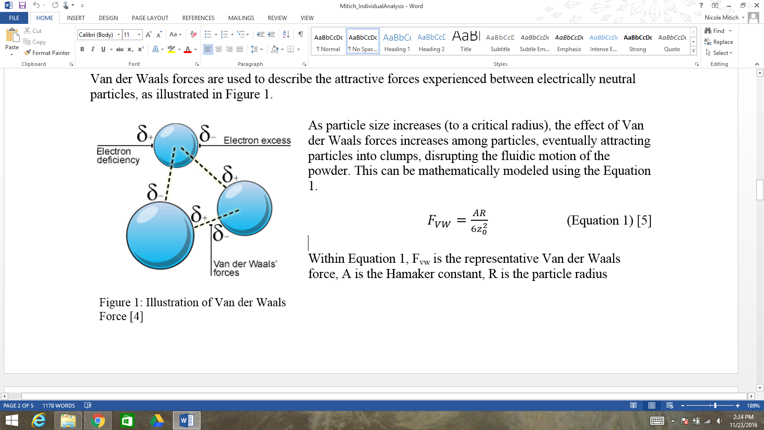 (Equation 2) [37]

Within Equation 2, F_{vw} is the representative Van der Waals force, A is the Hamaker constant, R is the particle radius (assuming the particle to be spherical), and z₀ is the distance between the two particles. By this equation, it is observable that the Van der Waals force is inversely proportional to the square of the distance between the particles and directly proportional to the particle size. Thus, particle size and Van der Waals forces are linearly correlated.

Electrostatic forces occur between particles that are oppositely charged, illustrated in Figure 24. These forces perpetually arise during particle usage as a result of contact electrification [35].
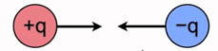
Figure 24: Electrostatic Forces between Particles [38]

Similar to Van der Waals forces, electrostatic forces increase with an increase in particle radius. Though unlike Van der Waals forces, they increase with the square of the particle radius. The experienced electrostatic force can be mathematically modeled by Equation 2.1.
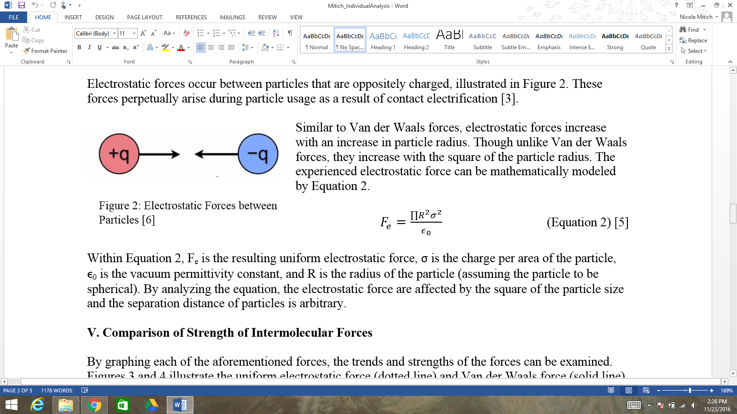 (Equation 2.1) [37]

Within Equation 2.1, F_{e} is the resulting uniform electrostatic force, σ is the charge per area of the particle, ϵ₀ is the vacuum permittivity constant, and R is the radius of the particle (assuming the particle to be spherical). By analyzing the equation, the electrostatic force are affected by the square of the particle size and the separation distance of particles is arbitrary.

By graphing each of the aforementioned forces, the trends and strengths of the forces can be examined. Figures 25 and 26 illustrate the uniform electrostatic force (dotted line) and Van der Waals force (solid line) as a function of particle size, and vary the separation distance.

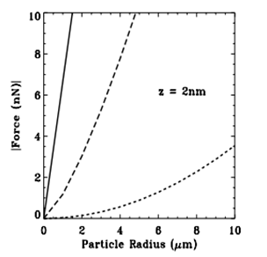
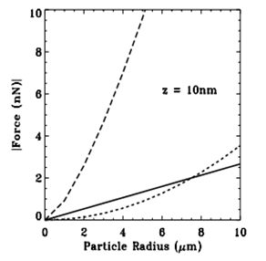

Figure 25: Intermolecular Forces at z = 2nm [39] Figure 26: Intermolecular Forces at z = 10 nm [39]

From these plots, it can be observed that Van der Waals forces have a larger effect on particle aggregation than electrostatic forces at small particle separations, and up until a critical radius (determined by setting F_{vw} = F_{e}) at larger radii.

Based on the provided information, there are two main intermolecular forces affecting the conglomeration and fluidic motion of powder particles: Van der Waals and electrostatic forces. Van der Waals forces increase linearly with increasing particle size, but are greatly affected by the distance between particles. Thus, with increasing separation distances, the Van der Waals forces decrease by the square of the distance. Conversely, electrostatic forces change by the square of the particle radius and are not affected by separation distances. Thus, at larger separation distances or with smaller particle sizes, electrostatic forces overpower Van der Waals forces. Despite the exchange of forces depending on particle size and distance, there is always intermolecular attraction occurring at microscopic levels.

Analysis of these intermolecular forces allows us insight into why a powder will most likely not behave like a fluid: aggregation of particles. Because the particles will need to be small (mircrometer to nanometer in size) to have any realistic fluidic movement, intermolecular forces will largely and inconsistently impact their movement, prohibiting them from continuously flowing like a true fluid. Because it will not behave accordingly, hysteresis will occur within the amplifier, resulting in the inability to implement it for practical use.

5.2.3 Individual Analysis #3: Effects of Hysteresis on Granular Shape

One of the necessary steps to figuring out if a powder can act like a fluid is to identify if the shape should be spherical, cylindrical, irregular or any other shape. This analysis will cover how the different shapes of the material will impact the overall performance of the system. Including, how the mechanics of granular materials will affect the hysteresis and performance of the amplifier.

Glass beads like Cenospheres are associated within the category of granular materials. Granular materials are common in our everyday lives from coffee, sugar, to salt, and sand. These granular materials are solids but under the right circumstances they can act like a fluid and even a gas. For example, when a container of sugar is tilted, the granules will act like a fluid. When that same container is shaken, the sugar will act like a gas with the granules bouncing off of each other as well as the walls of the container [40].

One of the main problems with a powder acting like a fluid is that irregularities in shapes causes the granular material density to be a variable. This variation is caused by random packing as well as friction between particles. Experiments of spherical steel balls have shown that the volume fraction of the densest “random close packing” (RCP) was measured as ν_{rcp} ≈ 0.64 [41]. Furthermore, experiments with equal size spheres on a regular lattice such as face centered cubic (FCC) or hexagonal close pack (HCP), the maximum volume fraction achieved was ν_{fcc} = ν_{hcp} ≈ 0.74. From this we can conclude that ¼ of the powder will have voids throughout. These voids will enable the powder to change shape once a force is exerted on the powder, meaning that the powder will not act as a complete incompressible fluid.

Another issue that arises when looking at spherical granular materials is the dissipation of energy between particles. When granules collide or slide past each other energy is lost due to inelasticity and friction. This is unlike gases and liquids where molecules and atoms can collide with energy being conserved [40]. This dissipation of energy creates a problem for using a powder in an amplifier because the force from the large piston will be absorbed by the granules colliding with each other. Also, this dissipation of energy makes it very difficult to be able to describe granular materials with theories like statistical mechanics. Furthermore, this loss of energy makes it impossible to have an amplifier with only a powder used as its medium. Hysteresis in the system would be inevitable because the dissipation of energy from the collision of the piston on the granules would swamp the effects of the output force from the Terfenol-D.

Osbourn Reynold discovered a theory called dilatancy which is the phenomenon when shear deformation of granular materials induces a positive change in volume. Physically, this can be explained by the fact that two interlocking grains first have to separate before they can move past each other [42]. Reynolds dilatancy theory is important because when transmitting a force through the amplifier the shear stresses will cause a change in volume of our powder medium and thus creating hysteresis in the system.

From this information gathered about the mechanics of spherical granular materials it is clear that a spherical powder alone cannot act as an incompressible fluid inside the amplifier. The volume fractional packing factor, dissipation of energy, and Reynolds dilatancy theory all create viable issues with transmitting the force of the Terfenol-D without hysteresis through the amplifier.

5.2.4 Individual Analysis #4: Fluid-like attributes in powders

The task assigned to the Honeywell Powder Amplifier team is to test if powder materials can be used as a medium in a mechanical actuator. This report will cover if powder materials have the ability to act like fluids. The phrase acting like a fluid will cover movement, compressibility, and hysteresis in the material. Shape and particle size of different powders will also be examined to shed light on what exactly causes materials to behave the way they do.

Particle size was researched to find out the exact size each powder particle must be before the entire system begins to act like a fluid. It was found that fluid particles begin to behave in a fluid-like way once a Knudsen number of less than one is achieved. The Knudsen number is defined below. Eqn (3) shows a direct relation between Mean Free Path of each particle (λ), and the Representative length scale (L). Mean free path of a particle is the average distance that particles travel before collision with another particle in the medium. [43]
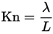 (3)
The Knudsen number is an extremely important factor in mimicking fluid flows. Below is a graph displaying six separate fluids and their corresponding Knudsen numbers. These numbers are directly proportional to the Y axis normalized flow velocity (V). As shown below the velocity of these flows increase as the Knudsen number is decreased.
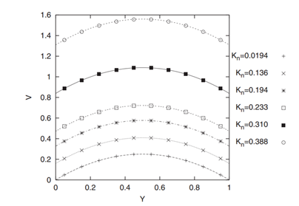
Figure 27: Knudsen Number graph [1]

Further research into particle shape has shown that the shape of a material greatly influences how each material flows. When focusing on smaller particles Van Der Waals forces must also be accounted for. These forces are the residual attractive forces between materials outside of covalent or ionic attraction. Van Der Waals forces play an important role in how extremely fine particles react as a whole. When fine particles such as metals are ground down to microscopic size or smaller the Van Der Waals phenomenon takes place, this phenomenon causes these finely ground materials to clump together and create a normal sized particle. The occurrence of Van Der Waals forces has a direct effect on flow due to increased particle size, therefore materials must be free of Van Der Waals forces in order to react with fluidic properties while inside the actuator. [44] One reason Particle shape plays such a large role in fluidic flows is the reduction of Van Der Waals forces based on shape. For example large aspect ratio materials are shown to have a much lower flow rate than their Spherical counterparts. [45] Below is a figure displaying the overall flow of four different particle shapes. These particles were all subjected to approximately 6kpa/m pressure and the velocity of the individual particles was calculated. This data confirms that for solid particles to behave like a fluid they must be of spherical nature.
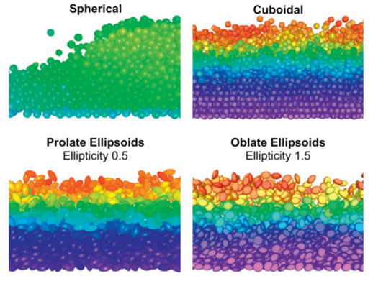
Figure 28: Shaded Velocity magnitude for differently shaped particles at 3 kpa/m pressure. [45]

Spherical possibilities were then researched further, one possible material that could be tested further is iM30k hi-strength glass bubbles. This spherical material has a diameter of approximately 18 microns, which in comparison is roughly 3 times that of a human’s red blood cell. [46] This material displays an isostatic crush strength of 28,000 psi which is much higher than required for the powder amplifier. It is recommended that iM30k be tested to discover whether hysteresis exists, as well as if the material can withstand continuous stress over long periods of time.

In conclusion, ground powder/metallic materials displaying fluidic behavior currently seems impossible. However certain spherical glass materials such as Cenospheres and iM30k glass bubbles have shown they are capable in somewhat replicating fluid flows. It is advised that spherical materials are further researched in the upcoming months, a test should also be planned using ASTM standards in order to test for hysteresis and degradation of the material over time.

5.2.5 Individual Analysis #5: Fluidization of Powders and the Fluidized Bed

Fluidization can be defined as the operation by which solid particles are transformed into a fluid like state through the suspension in a liquid or a gas [47]. This is achieved by using a fluidized bed. In a fluidized bed, a liquid or gas is pushed through the bottom of the bed and into a material with a small grain size, usually micro or nano particles. If a liquid is the fluid medium, the mixture is known as homogeneous. If gas is the fluid medium, the mixture is said to be heterogeneous. Fluid beds start as fixed beds. The particles in these beds are effectively solids because they are immobile, leaning against one another, and have almost full contact with the other particles it is surrounded by. Once a sufficient fluid flow velocity has been reached, the particles will be in the fluidized state. In this state particles are in constant, chaotic movement, and the distance between particles increases as the fluid velocity increases. This will cause the height of the bed to rise. The pressure drop in the fluid phase across the bed is constant and equal to the bed weight over unit surface of the bed cross section. This value is reached at the minimum fluidization velocity [48]. The Figure 29 shows a plot of pressure drop in the granular substance against the velocity of the fluid being sent through the material. It can be seen that the peak of this chart shows the minimum velocity of fluidization. This signifies the minimum velocity at which gas or liquid should be pumped into the granular material in order for that material to reach a fluid like state.
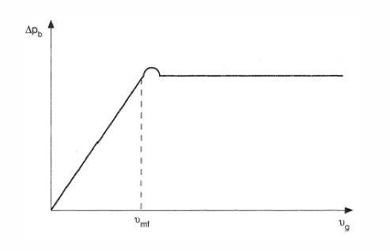

Figure 29: Pressure Drop vs. Velocity

The pressure drop necessary for fluidization to occur can be calculated using equation 4. In this equation, $ρ_{p}$and $ρ_{f}$signify the density of the powder and the density of the fluid, respectively. Pressure drop across the fluidized bed is equal to the ratio of the overall particle weight and the bed cross section. This equation assumes earth’s gravitational constant is present, both materials have different densities, and fluidization has reached steady state.

$∆P = (1-∊)(ρ_{p}-ρ_{f})gH$ Eq. 4

Where,
H = Height of the bed
g = Gravity
ε = bed porosity

There are several different types of fluidization. These types occur due to different grain size of the material being used. The first of these types is the non-bubbling stage. In this stage, the fluid does not penetrate the surface but rather expands the powder by widening the gaps in between particles. Figure 30 shows a microscopic picture of the gaps that can be seen between particles that have been fluidized.

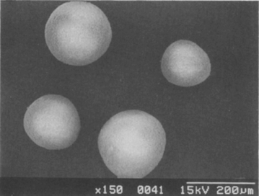

Figure 30: Fluidized Particle Gaps [50]

During bubbling, the granular material looks very similar to a boiling liquid. Particles are being pushed up by the bubbles and dispersed as the bubbles penetrate the surface. These two forms of fluidization occur due to particle size. Figure 31 shows a plot of Geldart’s powder classification. The lines signify different grain sizes that dictate the form of fluidization that will occur.
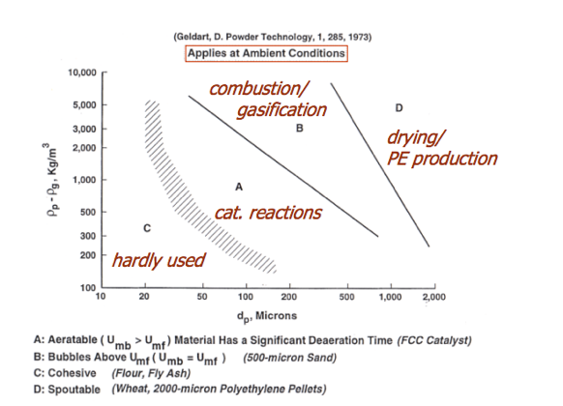

Figure 31: Geldart’s Powder Classification [49]

Also researched was the heat transfer in a fluidized bed. Within a fluidized bed heat transfer occurs on many levels. Heat transfer occurs in particle-gas heat transfer, heat transfer between points in the bed, heat transfer between the fluidized bed particles, the larger particles floating in the bed, and the heat transfer to the submerged surfaces in contact with the bed. One good aspect of having such high capability for heat transfer is that the temperature difference within the granular medium will never exceed 2-5°C even at temperatures as high as 1000°C [48]. If fluidization beds are the direction in which we decide to take this project, a full thermal analysis must be done on the material for which equations can be found in Fluidized Bed online resource.

Finally, Kusakabe et al. was used as a basis for forming potential design ideas. This paper discusses the fluidization of fine particles at reduced pressure. Using several different materials, an experiment was performed in which the material was placed in a long vertical tube of uniform cross section with air as the throughput. The results of this test show that fine materials can be fluidized at low pressures but some side effects occur under specific conditions including a quiescent bottom layer and a fluidized upper layer. Figure 32 shows the quiescent fluidization. If this were to happen in our system, the amplifier would be destroyed because of the two-phase powder. However, under the right conditions and through the use of a specific powder and pressure, a powder can operate as a fluid always.

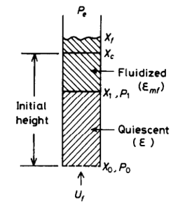

Figure 32: Quiescent Fluidization [50]

Although fluidization proves our main customer requirement of verifying that a powder can act like a fluid, there are many parameters that must be correct before a material can do so. A large part of fluidization is affected by the grain size of the material. Because a material has not yet been found or chosen, it is not helpful to perform a full analysis on the 4 different Geldart’s classifications. However, once a material is chosen it will be necessary to test this material in a fluidized bed in order to confirm that it will perform how we predict. Another thing that plays a large role in choosing this direction is the heat transfer within the fluidized bed. With the high capacity for heat transfer, it may exceed the limits of the outer housing. ASTM standard ASTM D7743 – 12: Standard Test Method for Measuring the Minimum Fluidization Velocities of Free Flowing Powders should be used when testing powders for fluidization in the future [51].

6 PROPOSED DESIGN

Upon further research and meetings with our clients, our team refocused several of our previous design ideas. Our Honeywell clients redirected our team to solely focus on the research and confirmation that a powder material can function as a fluid to amplify the magnetostrictive system in the actuator. Therefore, our final solution involves recommendations of materials based on our individual research and previously described individual analyses. The material will be required to meet our most important customer requirements, including acting as a fluid, produce no hysteresis, and having a thermal coefficient of expansion to adequately match our housing.

As a result, a large majority of the previously proposed designs in Section 4 and 5 have been eliminated from further consideration for our design project. Our clients specifically and vehemently told us to direct our efforts of this project to the research of a fluid-like material that meets the design requirements of the existing actuator, as opposed to making housing modifications or other design changes to the existing actuator.

With that client information, we will be utilizing the proof-of-concept actuator that was constructed by the 2015-2015 Honeywell Capstone team to test the thermal expansivity, output amplification, and hysteresis of the actuator if we find a powder that may act like a fluid. The actuator housing as well as a brief description of how it works is shown below in Figure 33.

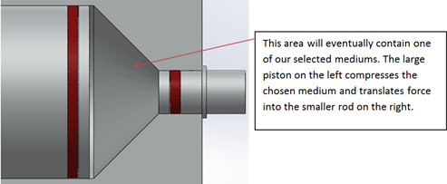
Figure 33: Powder Amplifier CAD Model

The proof-of concept Bill of Materials provided by the 2015-2016 Honeywell Capstone team is provided in Table 5.

Table 5: 2015-2016 Proof-of -Concept Bill of Materials
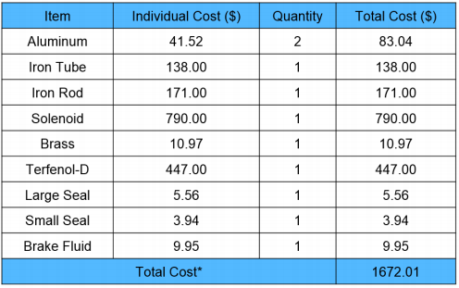

Because the intent of our project is to replace the brake fluid, the removal of the brake fluid from the amplifier will be the only alteration we make to the proof-of-concept prototype.

Due to the recent redirection of our project by Honeywell, a final design has not been selected. A clear design proposal has not been converged on due to this minor setback and therefore an implementation plan cannot be predicted. The conclusions taken from the Individual Analyses will be presented to our sponsor for further approval before we move on to the next steps of our project. Unfortunately, it can be concluded that a powder can only act as a fluid under very specific conditions. These conditions place more constraints to a problem that is already highly constrained by other mechanical and electrical demands. Implementation can come from a variety of different methods as mentioned above. However, any potential solution would also need to be tested in the future to ensure any predictions or calculations made beforehand, accurately represent the physical process taking place.

Appendix A: Pugh Chart


Figure 23: Pugh Chart
Appendix B: Decision Matrix


Figure 24: Decision Matrix

Appendix C: Volume Fraction Calculations

Volume Fraction for Solid Nanoparticle | φ = (ρβ)f - (ρβ)nf
 | (ρβ)f - (ρβ)s

 | Material | CTE | CTE Factor | Density | ρβ | VF Needed
 |  | ºC⁻¹ |  | g/cm³
Housing (nf)  [23, 31] | Titanium | 8.6 | 0.000001 | 4.5 | 0.0000387
Liquid (f)  [25] | DOT3 | 7.6 | 0.0001 | 1.12 | 0.0008512
 | (Diethylene glycol)
Nanoparticles (s)  [27, 29-30] | SiN | 2.8 | 0.000001 | 3.2 | 0.00000896 | 0.9647
 | AlN | 4.6 | 0.000001 | 3.26 | 0.000014996 | 0.9717
 | Diamond | 1.1 | 0.000001 | 3.175 | 3.4925E-06 | 0.9584

References

[1] M. Mike, "Magnetostrictive Torque Motor Project, Phase II", BbLearn, 2016. [Online]. Available: https://bblearn.nau.edu/bbcswebdav/pid-4686009-dt-content-rid-37760904_1/courses/1167-NAU00-ME-476C-SEC001-2176.CONTENT/F-%20Honeywell%20-%20Powder%20Amplifier%20Problem.pdf. [Accessed: 30- Sep- 2016].

[2] A. Bolyen, "Project Description", Cefns.nau.edu, 2016. [Online]. Available: https://www.cefns.nau.edu/capstone/projects/ME/2016/MagnetostrictiveTorqueMotor/. [Accessed: 30- Sep- 2016].

[3] J. Xiang, Exploring Robotics: Construction, 1st ed. Brooklyn: Brooklyn College, 2016, pp. 2-7.

[4] C. Simkins, "The role of hydraulic actuators within aircraft systems - Insight - Acorn Industrial Services", Acorn-ind.co.uk, 2012. [Online]. Available: http://www.acorn-ind.co.uk/insight/The-role-of-hydraulic-actuators-within-aircraft-systems/. [Accessed: 01- Oct- 2016].

[5] Experimental Aircraft Info, "Pneumatic Aircraft Systems Parts and Description", Experimentalaircraft.info, 2016. [Online]. Available: http://www.experimentalaircraft.info/articles/pneumatic-systems.php. [Accessed: 01- Oct- 2016].

[6] S. Mraz, "Servocontrol with pneumatic actuators", Machinedesign.com, 2016. [Online]. Available: http://machinedesign.com/pneumatics/servocontrol-pneumatic-actuators. [Accessed: 01- Oct- 2016].

[7] B. Praveen Kumar, "Design of Magnetic Actuator", International Journal of Research in Engineering and Technology, vol. 04, no. 10, pp. 370-374, 2015.

[8] C. Liu, T. Tsao and C. Ho, "Out-of-plane magnetic actuators with electroplated permalloy for fluid dynamics control", Sensors and Actuators A: Physical, vol. 78, no. 2-3, pp. 190-197, 1999.

[9] F. Claeyssen, "New Actuators for Aircraft and Space Applications", in 11th International Conference on New Actuators, Bremen, Germany, 2008, p. 352.

[10] "Smart•X, P1S2 (Titanium Housing)", Amloceanographic.com, 2016. [Online]. Available: http://www.amloceanographic.com/Smart-X-Titanium-Housing. [Accessed: 01- Oct- 2016].

[11] P. Van Gerwen, "DACS actuator", US9247357 B2, 2016.

[12] "EL-O-MATIC ACTUATOR WITH CSR COATING", Emerson, 2016. [Online]. Available: http://www2.emersonprocess.com/siteadmincenter/PM%20Valve%20Automation%20Documents/Elomatic/Pneumatic_Rack_and_Pinion/Technical_Data/420402.pdf. [Accessed: 01- Oct- 2016].

[13] "Cenosphere Properties", Cdn.shopify.com, 2016. [Online]. Available: https://cdn.shopify.com/s/files/1/0235/5803/files/CENOSTAR_cenosphere_property_table_Matrix_7.20.16.pdf?7192624926503384256. [Accessed: 01- Oct- 2016].

[14] M. Sistaninia, A. Phillion, J. Drezet and M. Rappaz, "Three-dimensional granular model of semi-solid metallic alloys undergoing solidification: Fluid flow and localization of feeding", Acta Materialia, vol. 60, no. 9, pp. 3902-3911, 2012.

[15] A. Soleimani Dorcheh and M. Abbasi, "Silica aerogel; synthesis, properties and characterization", Journal of Materials Processing Technology, vol. 199, no. 1-3, pp. 10-26, 2008.

[16] "GAMMA Seal, Rotary Shaft Seals, Shaft Seal - Trelleborg", Tss.trelleborg.com, 2016. [Online]. Available: http://www.tss.trelleborg.com/global/en/products_2/rotarysealsshaftseals/detailpages_shaftseals/gamma-seal.html. [Accessed: 01- Oct- 2016].

[17] "Rubber O Rings and Elastomer O Ring Seals from PPE", Prepol.com, 2016. [Online]. Available: http://www.prepol.com/product-range/O-Rings. [Accessed: 01- Oct- 2016].

[18] "Optimum® Syringe Barrel Pistons | Nordson EFD", Nordson.com, 2016. [Online]. Available: http://www.nordson.com/en/divisions/efd/products/accessories-kits-and-auxiliary-equipment/optimum-syringe-barrel-pistons. [Accessed: 01- Oct- 2016].

[19] "Select An Appropriate Cenosphere Manufacturer From India", Cenosphere Processing, Cenosphere from India - Durgesh Group, 2016. [Online]. Available: https://durgeshgroup.wordpress.com/2016/05/23/select-an-appropriate-cenosphere-manufacturer-from-india/. [Accessed: 29- Oct- 2016].

[20] "1st Class Lever", InnerBody, 2016. [Online]. Available: http://www.innerbody.com/image_musc04/musc73.html. [Accessed: 29- Oct- 2016].

[21] T. Hayat, S. Qayyum, M. Imtiaz and A. Alsaedi, "Comparative study of silver and copper water nanofluids with mixed convection and nonlinear thermal radiation", International Journal of Heat and Mass Transfer, vol. 102, pp. 723-732, 2016.

[22] S. Hawes, "UNIT 13: Thermal Conductivity and Thermal Expansion", Online (slideplayer.com/slide/4125022/), 2015.

[23] Bal Seal Engineering, "Coefficient of Thermal Expansion for Various Materials at Different Temperatures", Bal Seal Engineering Co., Foothill Ranch, CA, 2016.

[24] "Volumetric or Cubical Expansion Coefficients of Liquids", Engineeringtoolbox.com, 2016. [Online]. Available: http://www.engineeringtoolbox.com/cubical-expansion-coefficients-d_1262.html. [Accessed: 17- Nov- 2016].

[25] "Liquids - Densities", Engineeringtoolbox.com, 2016. [Online]. Available: http://www.engineeringtoolbox.com/liquids-densities-d_743.html. [Accessed: 16- Nov- 2016].
[26] X. Guo, P. Tong, J. Lin, C. Yang, K. Zhang, M. Wang, Y. Wu, S. Lin, W. Song and Y. Sun, "Large negative thermal expansion in (Ga0.7Cu0.3)1-xMnxNMn3 (x≤0.4), compensating for the thermal expansion of cryogenic materials", Scripta Materialia, vol. 128, pp. 74-77, 2016.

[27] "Nanoparticles & Nanomaterials | AMERICAN ELEMENTS ®", American Elements, 2016. [Online]. Available: https://www.americanelements.com/nanomaterials-nanoparticles-nanotechnology.html. [Accessed: 17- Nov- 2016].

[28] A. Kimouche, A. Mataoui, H. Oztop and N. Abu-Hamdeh, "Analysis of heat transfer of different nanofluids flow through an abrupt expansion pipe", Applied Thermal Engineering, vol. 112, pp. 965-974, 2016.

[29] "Coefficient of Thermal Expansion | Fine Ceramics (Advanced Ceramics) | Kyocera", Global.kyocera.com, 2016. [Online]. Available: http://global.kyocera.com/prdct/fc/list/tokusei/bouchou/index.html. [Accessed: 17- Nov- 2016].

[30] S. Kidalov and F. Shakhov, "Thermal Conductivity of Diamond Composites", Materials, vol. 2, no. 4, pp. 2467-2495, 2009.

[31]"ASM Material Data Sheet", Asm.matweb.com, 2016. [Online]. Available: http://asm.matweb.com/search/SpecificMaterial.asp?bassnum=MTU020. [Accessed: 16- Nov- 2016].

[32]"MATERIALS | CERATEC", Ceratec.nl, 2016. [Online]. Available: http://www.ceratec.nl/materials.html. [Accessed: 19- Nov- 2016].

[33] K. Rietema, The Dynamics of Fine Powders, 1st ed. Dordrecht: Springer Netherlands, 1991.

[34] P. Pritchard and J. Mitchell, Fox and McDonald's Introduction to Fluid Mechanics, 9th ed. Hoboken: John Wiley & Sons, Inc., 2016, p. 18.

[35] J. Visser, "Van der Waals and other cohesive forces affecting powder fluidization", Science Direct, vol. 58, no. 1, pp. 1-10, 2001.

[36] "BBC - Higher Bitesize Chemistry - Bonding, structures and properties : Revision, Page2", Bbc.co.uk, 2016. [Online]. Available: http://www.bbc.co.uk/bitesize/higher/chemistry/energy/bsp/revision/2/. [Accessed: 18- Nov- 2016].

[37] Clarkson University, "Particle-Substrate Interactions: Microscopic Aspects of Adhesion", Rochester, 2006.

[38] Z. Wissner-Gross, "Coulomb's Law", School Yourself, 2008. [Online]. Available: http://schoolyourself.org. [Accessed: 18- Nov- 2016].

[39] B. Gady, "MEASUREMENT OF INTERACTION FORCES BETWEEN MICROMETER-SIZED PARTICLES AND FLAT SURFACES USING AN ATOMIC FORCE MICROSCOPE", Purdue.edu, 2016. [Online]. Available: http://www.physics.purdue.edu/nanophys/thesis/gady.pdf. [Accessed: 18- Nov- 2016].

[40] Göncü, Fatih. Mechanics of Granular Materials: Constitutive Behavior and Pattern Transformation. TU Delft, Delft University of Technology, 2012.

[41] J. Berryman. Random close packing of hard spheres and disks. Physical Review A, 27(2):1053–1061, Feb.1983.

[42] P. Jop, Y. Forterre, and O. Pouliquen. A constitutive law for dense granular flows. Nature, 441(7094):727–30, June 2006.

[43] 2016. [Online]. Available: http://people.tamu.edu/~bmaggard/Advising/PETE_325_Lab_Descriptions/Lab%20Week%204%20VLP%20and%20Nodal%20Analysis/Week%204%20Lab%20InTech-Two_phase_flow%20M%20awad.pdf. [Accessed: 16- Nov- 2016].

[44] Nie, X., Doolen, G.D. & Chen, S. Journal of Statistical Physics (2002) 107: 279. doi:10.1023/A:1014523007427

[45]"General Chemistry Online: FAQ: Liquids: What are van der Waals forces?", Antoine.frostburg.edu, 2016. [Online]. Available: http://antoine.frostburg.edu/chem/senese/101/liquids/faq/h-bonding-vs-london-forces.shtml. [Accessed: 16- Nov- 2016].

[46]J. Hilton and P. Cleary, "The influence of particle shape on flow modes in pneumatic conveying", Chemical Engineering Science, vol. 66, no. 3, pp. 231-240, 2011.

[47] D. Kunii and O. Levenspiel, Fluidization engineering. United States: Butterworth-Heinemann, 2014.

[48] 2016, "Fluidized bed," 2010. [Online]. Available: http://www.thermopedia.com/content/46/. Accessed: Nov. 18, 2016.

[49] J. R. van Ommen and N. Ellis, "Fluidization,". [Online]. Available: https://www2.msm.ctw.utwente.nl/sluding/TEACHING/ParticleTechnology/vanOmmen_Fluidization.pdf. Accessed: Nov. 19, 2016.

[50] J. R. van Ommen and N. Ellis, "Fluidization,". [Online]. Available: https://www2.msm.ctw.utwente.nl/sluding/TEACHING/ParticleTechnology/vanOmmen_Fluidization.pdf. Accessed: Nov. 19, 2016.

[51] A. International, "ASTM D7743 - 12 standard test method for measuring the minimum Fluidization velocities of free flowing powders," 2012. [Online]. Available: https://www.astm.org/Standards/D7743.htm. Accessed: Nov. 19, 2016.

